1. Download the admin LTE and paste it inside the htdocs folder
2. Local Server - <https://github.com/ColorlibHQ/AdminLTE/releases>
3. Code editor - Check the timeline, multi level
4. Sublime personal settings Download the plugins
5. Comm-html-section + tab = comment section
6. Command + alt + n = create new file
7. Cmd + ctrl + G = select and replace similar selected characters
8. Admin LTE template
9. Plugins and extensions





* Morris chart >> <https://morrisjs.github.io/morris.js/>
* Date ranger picker >>> <https://www.daterangepicker.com/>
* Data tables >>> <https://datatables.net/>
* jVector map >>> <http://jvectormap.com/>
* jQuery knob >>> <https://github.com/aterrien/jQuery-Knob> and <http://anthonyterrien.com/demo/knob/>
* sweet alert >>> <https://lipis.github.io/bootstrap-sweetalert/>
* jQuery number >>> <https://plugins.jquery.com/df-number-format/>
* chart js >>> <https://www.chartjs.org/>
* tcpdf >>> <https://tcpdf.org/>

1. Rename the source code and sql to pos-copy and sql-copy

access phpMyAdmin, set up the collation to UTIF-8 name it as pos-copy, then create

import the sql-copy. Rename the database in /models/connection.php and use sql-copy

<http://localhost:8080/phpmyadmin/>

* Syblime text shortcuts = <https://gist.github.com/mrliptontea/4c793ebdf72ed145bcbf>

**Section 2 – AdminLTE and Model-View-Controller**

1. **Adapting adminLTE to MVC pattern**



1. Setup the MVC folders inside the htdocs:
2. Main folders

* model
* views >>> create a template.php and models subfolder. Copy the dist, bower components and plugin folders inside the views folders.
  + Copy the content of blank.html to template.php as a sample. Revise the link of the scripts and links to point to views
  + 
* controller

1. Create the ajax folder, this is the location of the js which will allow to interact to database using js.
2. Create the extensions folder, this will be the location for the plugins
3. Create the .htaccess
4. **Configure the controller**
5. at index.php,

“require_once “controllers/template.controllers.php”

do not close the php tag so the succeeding syntax are all written in php

$template = new ControllersTemplate();

$template -> ctrTemplate();

1. Create the template.controllers.php in controllers folder and create the ControllersTemplate class

Create a method under ControllerTemplate class in tempate.controller.php



1. Architecture:

Create the CRUD Manager methods for Users, clients, categories, products and sales using the CRUD inquiry to database and utilize the views -> controller -> models -> views pattern

1. **Adding module to POS system**
2. Advisable screen size to configure for web app

Mobile 320px

Tablet portrait 768px

Table landscape 1024 px

Desktop 1366 px

1. Customize the template.php
2. 



Do not use the min version.

1. Transfer the scripts on top before the head close
2. Create the template.js inside js folder. This is customize and will make the template.php be recognize by html. Add it at the bottom of the template.

This will be the main javascript file of the project. Remove demo.js in the head of the template.php. all the js to be execute will be written in template.js. this will replace the demo.js in the template.php

1. Delete the long <header> and <aside>, content-wrapper and <footer> make it as a module.
2. **Adding modules to POS system**
3. Open a php tag and change the syntax from html to php



1. Create the header.php inside the modules folder. Can copy the main-header section from index.html

Codes here >>> . Change the syntax to PHP

Start the code by opening and closing a PHP tag

1. Create the header.php



- Header.php content, can refer to main-header of the index.html under plugins folder

* + Logo; Create the img folder under views and create template and products folder inside it
  + Sidebar
  + User profile
  + Drop down toggle
  + Create the img folder under views and create template and products folder inside it
  + Output of the header.php



1. **Adding modules**

* Add the sidebar
* Create the menu.php inside the modules folder and include it in the template.php
  + This includes the side bar
  + Refer to content section of the blank.html
  + Output of the code

 

- Add the footer

* + Create the footer.php under \views\modules
  + Add and call it in template.php



* Create the content.php
  + Can copy the content section from the blank.html
  + Refer to content section of the blank.html
  + Output of the cont.php



1. **Creating the views, controllers and models**. Create the CRUD Manager methods for Users, clients, categories, products and sales using the view >>> controllers >>> models >>> view architecture

* Customize the content.php, suggest to remove the examples, change the blank page to dashboard and setup the hyperlinks later. This will be the main template of each pages
* Rename the content.pho to home and fix the hyperlinks at the menu.php and change the setup in template.php as content.php to home.php
* **Setting up the routing**
* Setup the .htaccess for the URLs, then use it in the template.php for routing purposes

.htaccess = 

template.php = 

* Fix the routing for other pages such as the users, categories, products and clients and sales



* Use the home.php as the template for each pages to fill up the side slide. Customize each page as per titles and required features
* **Setup the controllers**
  + Create the controllers for each page (users.controllers.php)
  + Setup the controllers in index.php
* **Setup the models**
  + Create the models for each page (users.models.php)
  + Setup the models in index.php

1. **Setup the 404 page**

* Create an else stamen in the routing of the template.php



* Create the 404.php inside the modules folder, use any of the page and customize it as a 404 page. Remove unnecessary parts of the page.
* Setup the favicon in template.php

1. **Login Page**

* Refer to login.html
* Configure the template.php to setup an if statement that the login page will be active if a user is not login, the class=”wrapper” will be active once a user login. Use the echo to set up the <div class=”wrapper”>

 >>>  >> 

* Create the login-page “login.php” with reference to login.html, customize if necessary
  + Use form method=POST
  + Change the email to user
  + Delete the col-xs-8, this will remove the “Remember Me”
  + Remove the facebook and google, forgot my password and register a new user links

 >>> 

* + Can change the background in AdminLTE.css, can use color or background image



1. **Start Session Part 1**

* Create the database named “spr”
* Create tables for user, products, customers etc.
* Do for user management db first with 9 columns namely:
* id, name, nickname, password, photos, status, save last login of the user and date of creation of the user and profile roles.
  + profile roles:
    - Administrator – can do everything, complete power
    - Special – can add, categorize products, administer stocks, can view users but can’t access to create users or print bills. Can delete and edit products
    - Seller – can access only customers and sales. Can create customer profile but cannot delete it.
    - All deletion can be done by administrator.
* Create the 9 table in the spr database, then save
* Create the admin user by clicking the “Insert” tab

 

* Configure the login method before the closing tag of form at login.php



* Configure the user.controller.php to define the class ControllerUsers and ctrUserLogin mentioned in login.php



1. **Start session part 2**

* Create the connection.php inside modules folder. This will define the db connection method.



* Configure the user.model.php to define the class UsersModel mentioned in the users.controller.php

 >>>

 >>> this will execute the session and will log on a valid user to “home” if the username and password is valid Call it in template. Php afterwards

* At templste.php, start thse session:



1. **Creating the log out function**

* Logout was called in header.php
* Create the route for the logout page in the template.php
* Create the logout.php under modules folder.
* Destroy the session in this logout.php by calling the method session_destroy()



**A complete mvc architecture was done at this point**

1. **Building User Module – Part 1**

* At users.php and other pages, set all the # to “home”. Customize the users.php and remove un-necessary features.
* Create the “Add User” button

 >>> 

* Create the table for user information





* Create the body of the table





Now lay out is finished

* Create the modal box, can copy the sample at w3-bootstrap

 

1. **Building user module – Part 2**

* Continue working on the lay out of the modal. Add the input number, username, password, profile, picture upload



1. **Data table plug in** – this will make the table appear better

<https://datatables.net/>

* Copy the <link> and <script> for the data table to template.php.





* Activate the code in users.php





* Call and activate it in template.js





* Make the app responsive in mobile device by adding responsive css and js:

Last 2 scripts



Last CSS



Add the dt-responsive in the table class



1. Adding users

* Create the users.html.php inside the modules folder
* Add some styling in users.php, in # field and apply it as well in users.html.php
* At “modal-form, in users.php open a php tag and create a php object before closing the modal form that will enable to save the user and add this info to database.



* Add “static” before “public” in every template. This will ensure that the function will work in any server.
* Close the connection to db for each successful transaction at users.model so that it will not execute in continuous way



-create the user registration in users.controller.php, this is in response with “newUser’ in users.php and the method called before closing the modal form.



* This feature can include the “SweetAlert” function (<https://sweetalert2.github.io/>). Copy the cdn script and create the “sweetalert2.all.min.js” inside the plugins\sweetalert2, then call it in template.php

 

* Continue working in saving data to db in users.controller.php



* Then work on the user registration in users.model.php

1. uploading user image

* Change the id to class for “newPhoto”, this will help to edit the user information.



* create a new js file named users.js, this will contain the java script for the user. Work on below photo upload code. The following js code will embed the photo in the photo box as below.

 

1. Adding User Photo – Part 2

Saving photo to in a folder

* 1. In users.controller.php



Saving photo to in database

* 1. Make the $photo = “”, to be validated



* 1. Add the $photo in $data array of the users.controller.php



* 1. Execute adding to db by configuring it in users.model





* 1. It now adds photo successfully with sweet alert



Save photo data in directory



Save it in db



1. Encrypting the password - utilize the crypt(a, b) of php in users.controller.php

a = parameter, b = salt

use the crypt_blowfish, safest crypt



It will encrypt the password of the new user added



Adjust the comparison of password during login.





The user can now login with encrypted password

1. Create sessions – this will able to allow the system to know who are the users that logged in. this will

improve some of the layout of the page like display the profile picture and indicate the username in the

header. 

25. Create sessions – this will able to allow the system to know who are the users that logged in. this will

improve some of the layout of the page like display the profile picture and indicate the username in the

header. 

1. in users.cntroller.php, create the $SESSION variables of each db columns
2. 
3. At header.php, customise the profile picture and name. the if statement will make the profile picture of the user as default if the user didn’t upload a picture.



This will display the name and username of the user



24. Encrypting the password - utilize the crypt(a, b) of php in users.controller.php

* a = parameter, b = salt
* use the crypt_blowfish, safest crypt
* 
* It will encrypt the password of the new user added
* 
* Adjust the comparison of password during login.





* The user can now login with encrypted password

25. Create sessions – this will able to allow the system to know who are the users that logged in. this will

improve some of the layout of the page like display the profile picture and indicate the username in the

header. 

* in users.cntroller.php, create the $SESSION variables of each db columns
* 
* At header.php, customise the profile picture and name. the if statement will make the profile picture of the user as default if the user didn’t upload a picture.



This will display the name and username of the user



26. Selecting users and display it in the USERs main page. Replace the static display with the dynamic data

of the users from database.

* Open up a php tag to create the object to define how to display the users from the database in users.php. can remove the static users rows

 >  >>

* The $item and $value will be accepted in the method ctrShowUsers in the users.controller.php and be evaluated at users.model.php
* Create the function in the users.controller.php, the method mdlShowUsers will be connectedneed to be connected to ModelUsers.



* Create a foreach for the array data to display it properly to the webpage in users.php. echo the template format of the users table and make the static data be dynamic. Create a condition for the photo field just in case the user did not upload photo



27. **Editing Users** – give power to edit the accounts by the Administrator profile when the pencil icon is press

* Assign a data-toggle function to fa-pencil in users.php



* Create the editUser, can utilize the existing modal for addUser. Change all the “new” to “edit” in each name property
* Change the “placeholder” to value, this will be the display view when we retrieve the data from db
* Setup ajax so that the database can be access via javascript add the btnEditUser in the class of fa-pencil and assign an id as idUser=”’.$value[“id”].’”. Create the user.ajax.php
* In users.js, setup the js to invoke the ajax



* Setup the ajax



* Assign an id of each element in the modal (name, user and profile). This will receive and display the data from db and display it in the modal when edit/pencil icon is click



* Then setup in users.js to retrieve the data from db



* The modal can now display the data from db



1. Editing User – Part 2

* Adding the picture, in users.js.



* In password field of users.php, create a hidden input with an id of currentPasswd and name of currentPasswd. Do the same with the photo. This is if in case the user did not update the all the fields in the modal.



* Activate and rename the $createUser to $editUser, then create the EditUser in users.controller.php



EditUser controller



  

* Create the user model



Users.js



* Create the ajax



* **Initially did not worked. The “editUser and “EditUSer” created some confusion. Ended up using EditUser in JS**

1. Activate and de-activate User Status

* Defining the status of the user. In users.php, profile section, check the status of the user by creating an if statement



* Make the user unable to access if account is deactivated. In users.controller, at login section, create an if statement to check the user status.

 

* Activate the account once the “Deactivate” is press
  + Create a btnAcivate in profile section of the usrs.php
  + Create a function to execute when the deactivate button is press in users.js
  + Create a idUser in the buttons with the $value[“id”] and the userStatus to be called in users.js



* + At users.js,
  +  
  + By the help of ajax, update the database. Setup the ajax, create the ajaxActivateUser

 



* + Create the mdlUpdateUser in users.model.php



* + Update the users.js to include the changing of status everytime the button is press

1. Last login –

* In users.controller, in login portion before going back to homepage



1. Avoiding repeated usernames

* In users.php, newUser section, create an id=newUser.
* In users.js, create the js to call the ajax and ask to check if there’s a user duplication

 

 <<< this fix the alert and remove the alert after a new input in the username field

* Use ajax to check in database if there’s any duplication. Declare public the $validateUser and create the method ajaxValidateuser(){} that will connect to the database.

 

* Create the object to validate the user



1. Deleting users – activate the x button, it will pop an alert to ask if the user is sure to delete the registered user. N to confirm before finalizing the delete.

* In user.php, fa-times, put a class btnDeleteUser



* In users.js, create the javascript to delete the user and invoke the sweet alert to confirm deletion

>> 



If click yes,



In users.controller, create the ctrDeleteUser function

* Create the mdlDeleteuser in users.model.php



* Enable the DeleteUser in users.php



1. Internet explorer debugging

* Use “<script type="text/javascript" src="https://cdnjs.cloudflare.com/ajax/libs/core-js/2.4.1/core.js"></script>

” to fix the bug for intertnet explorer plugin.

* Use width 100% for all the pages to properly display the pages.
* Use the normal function instead of arrow function.

1. Solution for click’s action on hidden buttons

* The issue is in the mobile view, the user information is not displayed when edit button is press, it doesn’t pull out the info from db. This is because the html was loaded already prior to the pressing of the + button thus it did not display the html when the fa-pencil is press

 

*  >>> 
* The correction will make the html be displayed on the document and display the .btnEditUser class to be display when the fa-pencil is click, it will display the info from database
* Do this similarly with btnDeleteUser and btnActivate
* Update the sweetAlert in btnActivate to display it properly in mobile device.

Section 4 – Categories Module

1. Build the CRUD for Categories module

* In categories.php, create the similar table that was created in users.php. we can again use the dataTables plugin, can use the users.php as the base
* Customize the page base from the requirement for categories

1. Adding Categories (C-RUD)

* Declare the controllers in categories. Pphp
* 
* Create the ControllerCategory and ctrCreateCategory in categories.controller.php

 

* Create the categories table with 3 columns in db
* Create the category.model, create the CategoriesModel and the class mdlAddCategory.
* Detect duplication in JS (optional), create also the ajax to detect duplication

1. Selecting Categories

* In categories.php, create the calling of categories. Open a php tag and create
* 
* Create the method ctrShowCatergories in categories.controller.php.
* 
* Define the model



* Create the forEach to display the array in the page



1. Edit Categories

* Reuse the add category modal and customize base from the reqt of the categories
* Create the JS fir edit category
  + Add a class id of EditCategory, btnEditCategory and idCategory=”’.value[“id”]. In fa-pencil
  + Add the categories.js in the template.php as a js source
  + In categories.js



* Create the ajax



* Create the categories.controller.php,



* Create the mode



1. Deleting a category

* Assign “btnDeleteCategory” to fa-times.



* Create the js in categories.js



* Create the Delete controller



* Create the delete model



* Add the modules to call in controller.php



1. Building Product Modules

* Create the layout for the Parts module, can use the users.php as the base. Cutomize it base from parts info requirement



* Create the modal with respect to add part requirements, include the Buying and Selling Price in a div with class col-xs-6 to put it side by side. Add the % box.



* Add the % box



1. iCheck Plugin

* <http://icheck.fronteed.com/>
* Add the iCheck plugin source in template.php.
* Add the iCheck plugin codes in template.js
* 
* Use the AdminLTE forms as a base.

1. Selecting Products (Read)

* The idea here is to add products not one by one via form but via a csv file or excel file
* Create the part table in the database with 10 columns (id, id category, code, description, image, stock buying price, selling price, number of times product was sold, date)
* Create an excel file same as the column structure of the db
* Save it as csv separated by commas file.
* Import the file in db as “CSV using LOAD DATA”
* Create the $parts in parts.php.



Note: $item = null and $value = null will import all data from db and display it in html.

* Create the ControllerParts and ShowParts in parts.controller.php
* 
* Create the class PartsModel and method mdlShowParts in parts.model.php
* The method will ask if the $item = null



* It can now display the array



Comment the var_dump and print the data in the table by making a foreach in parts.php and supply the column name to the html.

Note that there’s an issue with the use of the variable $value, turn around is to assign different names of $value and $values. It seems that the confusion is when the ControllerCategory::ctrShowCategories was re-use. That’s why the author used $valor and $value, another confusion brought is the reference is different from the video. **Get BACK ON THIS**.



1. **Dynamic Data Plugin – Part 1 >>> Very good chapter for AJAX and JS**

* The last codes are bringing and printing all the parts in the html and it’s going to be a heavy task if let’s say the item becomes thousands. This can be improve by making it dynamic using the dataTable plug in. this lots of information will create performance issue for the server (datatables.net).
* At parts.js, load the dynamic table
* 
* Create the datatable-parts.ajax.php
  + 
  + Create the class PartsTable
  + Create the function showPartsTable
  + Create the object Activate PartsTable and showPartsTablle
  + It takes time to be able to pull out the echo ‘hello’ in the console because of the parameter used in the parts.js which is answer. It seems that it creates a conflict as the parameter answer was also used in other modules. Ended up, used the parameter “ans” as the reply from the **datatable-parts.ajax.php. 2nd part, it seems that the real error is because I did not declared the parts.js in the template.php**.
  + Delete the <tbody> section of the parts.php. this is because we utilise the js in (<https://datatables.net/examples/ajax/simple.html>). This is to improve the loading performance and use js and ajax to load the table dynamically.
  + 



1. Dynamic Data Table – Part 2

* Objective is to load the picture and the buttons
* Create the html structure in the datatable-parts.ajax.php for the buttons and photo.
* 

* Create the ajax to bring all the info from database
* Link the parts and categories controller and model in datatable-parts.ajax.php
* 

1. Dynamic Data Table – Part 3

* Main objective is to have a color coding depending on the stock level and to use the buttons.
* In datatable-parts.ajax.ph,
* 
* Make the buttons work. Need to capture the id of each product. Add a class btnEditPart, idParts data-toggle and data-target=”#EditPart”. Create the js in parts.js
* Create color coding for the stock depending on the qty.
* 
* True will make optimize the loading.



1. Adding Products part 1

* Configure the modal
* Making the category field dynamic



* Update the code field automatically upon selection of the category.
* Auto increment of the code if code id increased. Let’s say if the last code is 109 for category 1 and I add, the code should show 110.
* The modal can now display the list of categories



* Capture the last code registered and auto increment it
* Add id and name “newCategory” in fa-th



* In parts.js,



* In parts.ajax.php, create the class AjaxParts and inside this, create the method. This will pull out all the data from db with respect to idCategory number.



* This will now show the starting number of the code like 101, 201, 301 etc in the console.
* 
* In parts.model.php add “ORDER BY id DESC” so that it will display the laast number of the code.



* In parts.js, add “+1” in Number(answer[“code”] + 1), so it will add 1 to the last code
* , it’s now adding 1 base from the last code and this is to be assign to the new part.
* Set the newCode number to readonly so the user has no chance to edit it.

The if statement below address the new Categories issue of “null” or undefined.

* 
* Here the new code is now 601 (from 5 + 1 = 6) and + “01”.



1. Adding Products Part 2

* Setup the selling price to be auto compute base from the “Use Percentage”.
* Assign an id to both buyingPrice and sellingPrice.
* Create the js for the sellingPrice.



* Create the JS when % change
* 
* 
* Above enabled the auto compute of the price versus the “Use Percentage” value, the check button is functioning. It makes the selling price readonly and non readonly
* Enable below in parts.php to save the data to db



* In parts.controller.php, create the 2 methods.

 

* Create the model.



1. Allowing Decimal Prices

* Add “step=”any””, in newPriceBuy and newPriceSell
* Correcting the font size in mobile view

 

1. Uploading Part Picture

* Activating the “Upload Photo” button ion parts.php, can use the codes from users.php and users.js for the photo upload
* Validate if image is set in parts.controller.php, can use also the code from users.controller.php
* Modify the parts.controller to suit the photo related requirements like the directory, and newUser to newCode

1. Editing the part

* Re-use the modal that was used in users.php
* Change the ids and classes appropriate for editing the parts
* Do not edit the category and code as it should be permanently assigned
* Create the parts.js
  + Define the js top call the ajax
* 
* Create the parts.ajax.php

 

* This will now bring the nfo from the db



* Bring the category of the products in parts.js
* 
* We have now the id and category
* 
* Pull out the other information, we have now the info from db displayed in the modal

1. Editing Parts – Part 2

* Make the selling price readonly.
* Duplicate the behaviour of the checkbox from addPart to make the editPriceSell active and in-active
* 
* Add the #editPriceBuy in the math section to be able to update the #editPriceSell when there’s a change in buying price.
* Add the #editPercentage in the math section to be able to update the #editPriceSell when there’s a change in the percentage price.



* Execute the method ctrEditPart
* 
* Create the ctrEditPart method in parts.controller.php. can use the code of the create parts. Edit the code corresponding to EditPart
* Create the parts.mdel.php



1. DELETING Products

* Inparts.js create the js for deleting the part. Ensure to assign the btnDEletePart in dataTable-parts.js
*  >>> this will show the idPart in the console 
* Capture the image and the code so that we can delete the file and the folder. Add the sweet alert to confirm user wants to delete the part and setup the window location of the deleted part



* Output of the code:



* In parts.controller.php, create the method delete product



* Create the mdlDeletePart in parts.model.php
* Include the ctrDeletePart in the parts.php



1. Build Client Module – similar to the code of the categories

* Create the layout, can use the categories.php and rename it to parts-user.php. use the advance element plugin of the forms



* Open the advance.html from AdminLTE package and look for the “Input Mask” part. Copy and link the Input Mask js to template.php
* 
* Copy the js code in template.js



* It’s now displaying the mask in phone number and birthdate



1. Adding Parts Users to database

* Create the Parts Users Database with 9 columns (id, name, idDocument, email, phone, address, birthdate, partsWithdrawn, lastWithdrawn, registerDate)
* 
* Define the PartsUser method



* Create the method in PartsUser.controller.php and create the ControllerpartsUser

 

* Create the partsUser.model.php and create the class ModelpartsUser and method mdlAddpartsUser inside it.



* It can now save data to db
* 
* 

1. Selecting Clients

* In partsUSer.php, define the class ControllerpartsUSer and method ctrCreatepartsUser



* Create the class and method in partsUser.controller.php

 



* Create the partsUSer.model.php and create the ModelpartsUser and mdlShowpartsUser inside it.





* PartsUser can now be viewed in the webpage



1. Editing Part User

* Assign in fa-pencil of the partsUser.php
  + Data-target = EditpartsUser
  + Data-toggle = modal
  + IdpartsUser = “’.$value[“id”].’”
* Utilize the add partsUser code for the edit
* Create the partsUser.js to call the ajax and get each info from db



* Create the partsUser.ajax



* Saving the new data
* Assign a hidden tag in the EditpartsUSer in partsUser.php and assign to it the id in the partsUser.js





* Create the edit controller in partsUser.controller.php. Can use the create user as a base code and customize it for edit





* Create the partsUser.model.php, can use the CreatepartsUSer as a base then edit top match the mdlEditpartsUser



* Can edit and save now the data to db



1. Deleting the Parts User

* Assign btnDeletepartsUser in partsUser.php
* Create the js to delete parts users
* 
* It can now display the parts User id
* 
* Create the sweet alert to confirm deletion of parts user





* Receive the variable get in the controller, create the method DeletepartsUSer in partsUSer.controller .php



* Create the partsUser.model.php, can use the delete user code base





It can now delete the parts user from the web and db



1. Building the Sales Module

* Take one file as a base, let’s say partsUser.html.php and save it as withdrawn.php. format the html that corresponds to parts withdrawal info.



* Create an href to link to create parts withdrawal page
* Use the withdrawn.php as the base code for createWithdrawal.php, customize it
* Create a modal box for the “Parts User” button. Can use the modal box in partsUser.php
* Note, below code hide it in mobile mode



Final Outcome



1. Building Sales module part 2

* Continue working on the Parts Withdrawal Page, see withdrawParts.php





1. Adding sales Part 1

* Create a new talke called withdrawal in the db, need to add columns for id, code, idPartsUser, idIssuer, parts, tax, net, total, paymentMethod, date



* Configure the withdrawal table. Configure the idPartsUSer and idIssuer as below



* Link also the parts to categories



* Actual db design relation



* Work on the “newIssuer”, it will display who is logged in.







* The <input type=”hidden”>. Will save the data to withdrawal table under idPartsUSer



* Configure the billing code. Open a php tag to check if there’s a withdrawal prior.



* Create the ctrShowWithdrawal in withdrawal.controller.php



* Create the withdrawal.model.php and create the method to ctrShowWithdrawal
* It shows 10005 because this will be the new parts withdrawal as there’s 4 withdrawals already in the db





* Work on the Parts User Input, reuse the ctrShowControllerpartsUser which was already created





1. Adding sales – Part 2

* Work on the table in the right side to bring all the parts displayed. Delete the tbody of the layout.
* Create the withdrawal.js and create the ajax for the data-table
* Include the withdrawal.js in the template.php
* It can now capture the data from db



* Display the JSON data to the table by defining it. Reuse the datatable-parts to datatable-withdrawal. Configure the withdrawal.js and use the class tablesWithdrawal in the ajax code. Change the path of the JS code





1. Adding sale – Part 3

* **Adding a part in Create Withdrawal form using the Add** Button under actions. Comment out the lay out as the intention is to add parts vis js.



* In withdrawal.js,
*  this will display the idParts



* Create an ajax to get the description, stock and sellingPrice form db



* Append the commented codes earlier from Parts Input of the createWithdrawal.php. add ‘’+ in each line to correct the html error inside the javascript



* **Create the delete button** for if the Part User decided not to take the part but already added to the button
* In createWithdrawal.php, create the .formulaWithdrawal in the beginning of the form. Then use it in withdrawal.js
* 
* Add the .removePart in fa-times. Create the js to remove the row
* The 4 parent() are for the 4 elements to be deleted
* 
* Activate again the previously disabled button. Assign an idPart to fa-times to capture the id of the disabled button.
* 
* 
* Final outcome, can add part, remove it from the list and the Add button is again enabled.



1. Adjustments to adding sales

* Fixing the bug in the add button (it can’t be added again after it returned active) and the add button is in-active state if x is press and the item is in the other page.
* In withdrawal.js at remove part, create the javascript to
  + add part in the sale form
  + remove part from sale form and enable again the Add button
  + remove part from sale form and enable again the Add button and be able to add again the part to part withdrawal form
  + remove part from sale form and make it enable again in any given page



* Should not be able to add the part to withdraw if the stock is 0.
* Add an if statement to add the part if the stock is

 

1. Adding Parts in mobile device - use of the children and parent

Enabling the hidden “Add Part” in tablet mode. Assign a class btnAddPart



* Create its JS so it will add parts upon clicking the hidden button. Add the “getParts” in the parts.ajax.php

 



* Copy and append the html of the .newPart and differentiate the 2 .newPart
* Create a forEach for the answer.



* This will bring the parts available in the dropdown



* Selecting Parts

 









1. Adjusting adding products from devices – use of the children and parent

* Fix the part duplication. In withdrawal.js, above the btnAddPart,
* 
* Then concat in the newPartDescription
* 
* Avoid adding part when stock = 0



1. Modifying Parts Quantity and the price auto adjust by the use of the .newPartQty so that it can be use in both datatable and mobile device



Don’t forget to add in the class the enterPrice in both modile and desktop html.

* Add an attribute realPrice in both mobile and desktop to fix the multiplication product because the last price is being multiplied to the qty.



* Adjust the stock quantity when part is withdrawn



1. Calculating the price of the added parts

Below code creates an array of the prices of the Parts about to be withdraw





* This will add and subtract prices of the parts





* It can now display the total price in the total box





* Fix the bug in the total price when all the parts are deleted. In the remove part area, create an if statement. This will make the value = 0 if no more part in the withdrawal form.



1. Adjusting to modifying product quantity and if we exceed the qty of the stock. As if it exceeds it automatically compute the price and it retains it when the sweet alert message is press. The price return to original price





1. Adding tax

* Add total=”” in newPartsTotalSell





Add hidden in the createWithdrawal.php in the tax area







Now tax is now included in the computation



1. jQuery Number plug in – used to give format to numbers

* <https://plugins.jquery.com/df-number-format/>
* Try a demo
* 
* Copy the plugin source (<http://opensource.teamdf.com/number/jquery.number.js>), paste it in views/plugins/jqueryNumber/jquerynumber.min.js
* Apply it in template.php and apply it in withdrawal.js, all fields using the price (mobile and desktop mode). Remember to use text instead of number for element having price and to be use the jQuery Number plugin

 

1. Adding Payment Method – either cash, credit or debit card

* In createWithdrawal.php, assign a value of each payment method



* Comment out below part



* Create a div for class cashMethod



* In withdrawal.js



* Cash box method will now appear when cash is selected





* Add the getCashChange input





* Format the price



* For credit and debit cards





* Do the math for payment method – cash change



* It will now compute for the cash change



1. Grouping products in JSON Data – save parts withdrawn in one cell of the database

* Below will create a JSON in the console

 

* Auto adjust the stock qty, assign NewStock in the newPartDescription





* This will now subtract the stock base from withdrawal, from below the qty becomes 9 to 6



Save the withdrawal to db. Use of JSON.stringify

In the createWithdrawal.php, Parts Input,



Then in withdrawal.js.



1. Organizing input data to save the withdrawal

* Saving to database will refer to the:

code = $_POST["newWithdrawal”]

idPartsUser = $_POST["newpartsUser”]

idIssuer= $_POST["newIssuer”]

parts = $_POST["partsList”]

tax =$_POST["newTaxPrice”]

netPrice = $_POST["newNetPrice”]

totalPrice = $_POST["saleTotal”]

paymentMethod = $_POST["newPaymentMethod”]

create the js for paymentMethod

 

It can now capture the mode of payment in the console



1. Updating parts and partsUSer table when saving a withdrawal

* Create a new input in newPartsTotalSell, this is to remove the format of “,” and “.00” as it can’t be save in the database
* 
* In the withdrawal.controller.php create the withdrawal





In parts.model.php, to update the db



In partsUsers.model.php, to update the db



1. Select and display withdrawal

* In withdrawal.php, <tbody> area, create the php to execute the show Withdrawal method



* It can now display the withdrawal made



* Work on the real value to appear from db.



1. Editing sales – Part 1

* Update the lastWithdrawn column of the partsUser db.
* In withdrawal.controller.php



* Call it in partsUser.php



Actual



* Enable the edit button in the withdrawn page. Create the editWithdrawal.php. add the fa-pencil in withdrawal.ph and enclose inside an anchor.
* In editWithdrawal,







1. Editing Sales – Part 2

* Change the fa-pencil address to



And assign the address in withdrawal.js

* And create the Edit Withdrawal in withdrawal.js



* In editWithdrawal.js, Change the S_SESSION to





* Get the value of the issuer of the part



* At CODE INPUT area,



* For partsUser







* For parts Input





* It can now retrieve the parts withdrawn previously



* Display it now in the webpage. Utilize the code used in .newPart





* For taxes and total Price





Define the method editWithdrawal, utilize the codes in withdrawal.contorller.php and change the new to edit



Define the account power of administrator, seller and special accounts

1. Editing Sales – Part 3

Create the controller for part edit

Create the model for the edit

1. Deleting Withdrawal

* Fixing the error when the only edited info is the payment method. It will not return a JSON data. It did not store back the parts initially withdrawn.





* Create the if statement in the withdrawal.controller.php (edit withdrawal),







* It can now display the correct edited information



* Fix the issue if the quantity of the part reached 0 and an edit needs. The quantity should still be 0 but it adds up.
* At withdrawal.controller.php,



Item remains 0



1. Adjustments when editing the sales – Part2

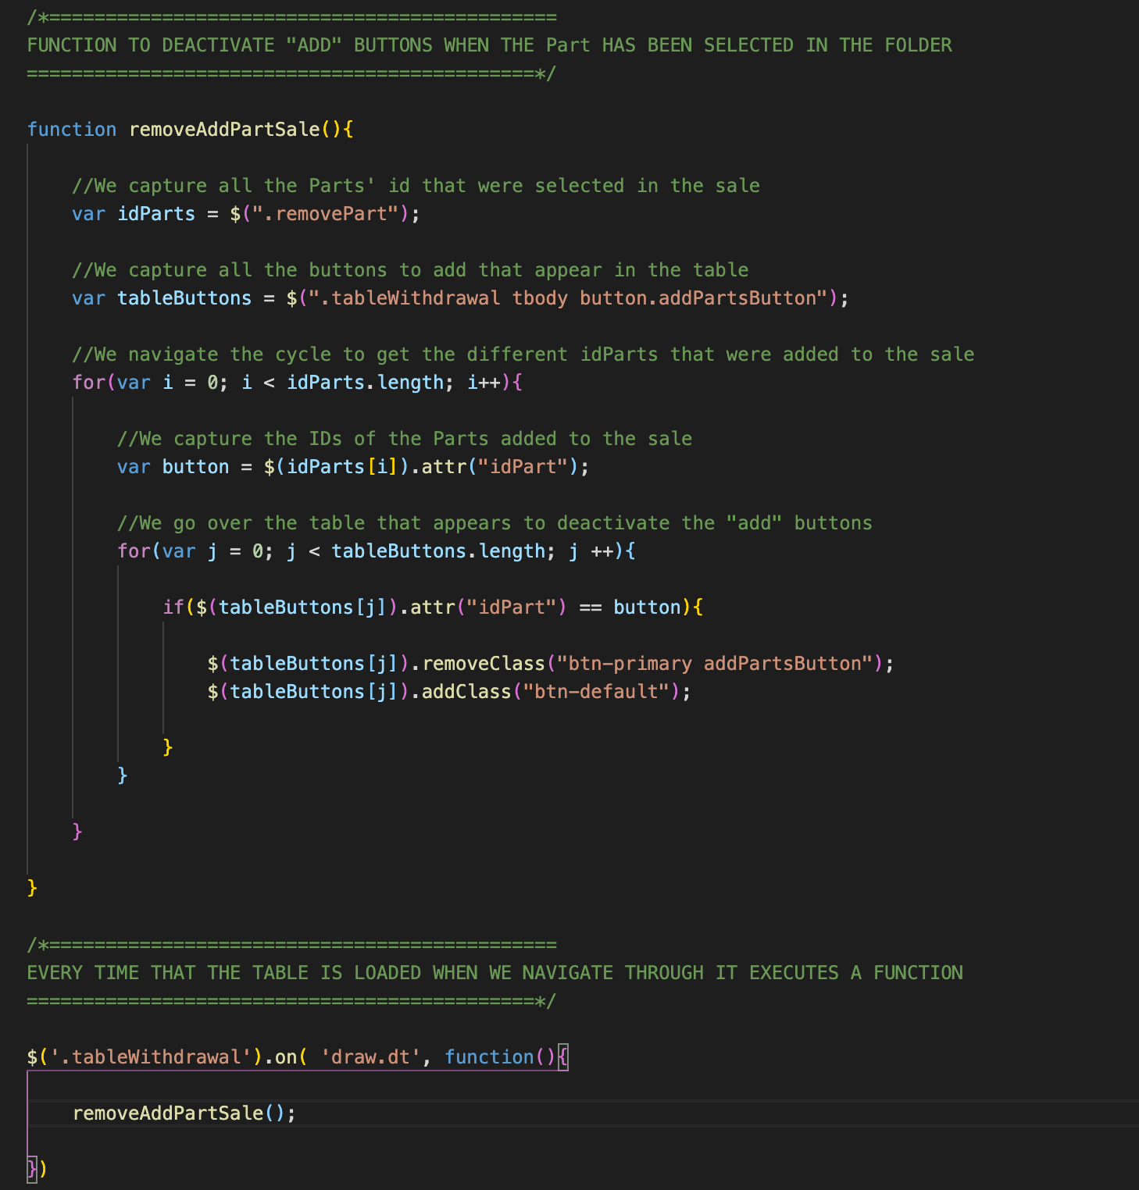

1. Changing taxes when editing a withdrawals

* Assign the netPrice php to totalSale



1. Deleting withdrawals

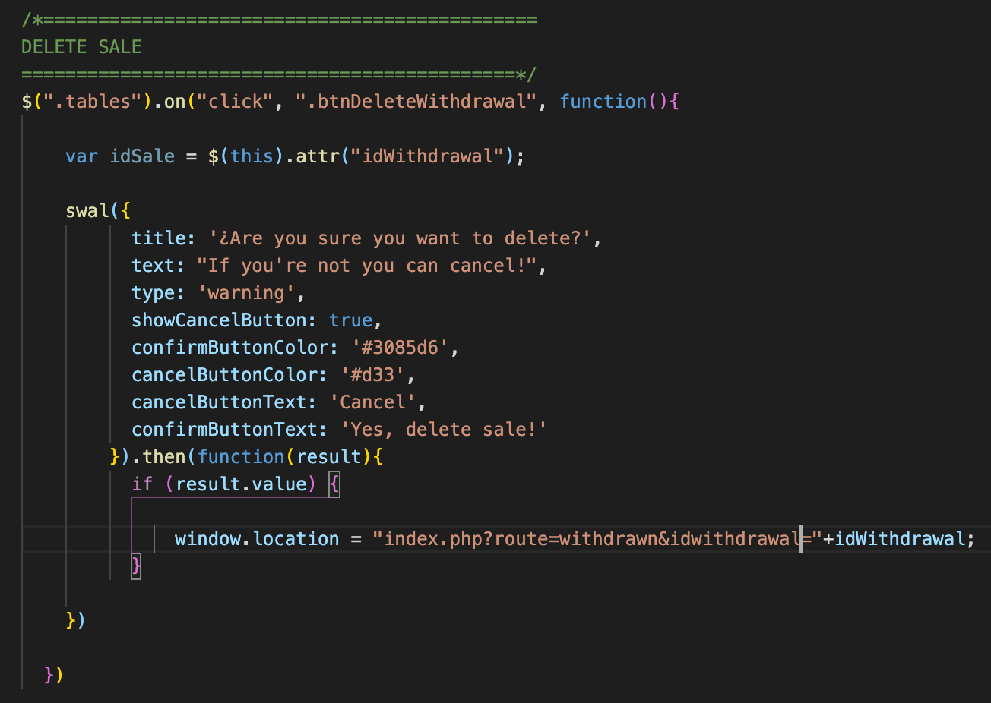

1. Procedsss for discovering errors
2. Printing PDF Invoice

* Configure the blue printer button. Utilize the plugin tcpdf “<https://tcpdf.org/>”.
* Download the tcpdf from github <https://github.com/tecnickcom/tcpdf> and put it in the extensions folder of the project
* In sales.php, .btn-info
* 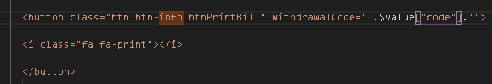
* In withdrawal.js
* 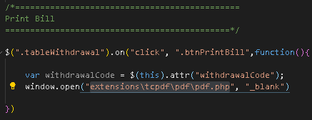
* Output as below
* 
* Create the bill.pdf inside the pddf folder, refer to pdf.php

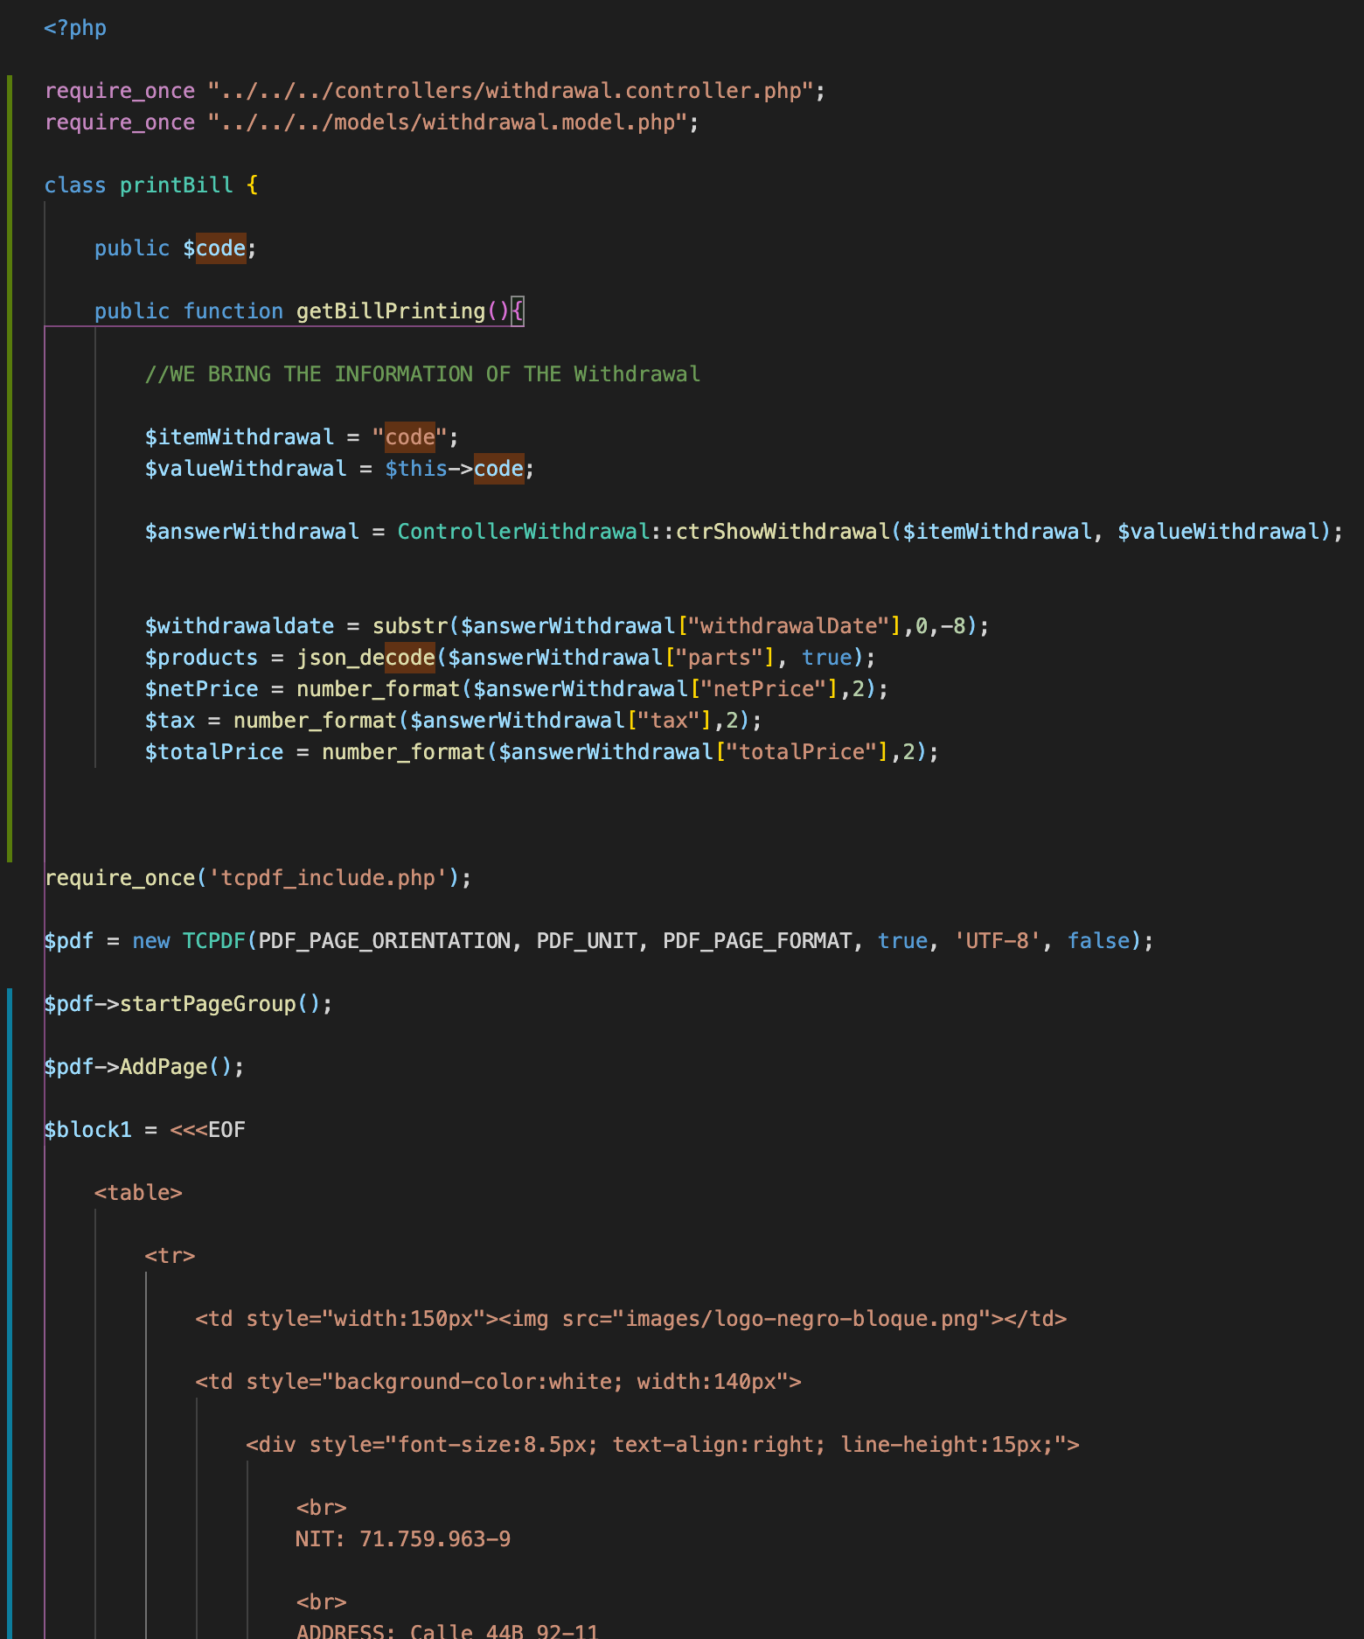

1. Printing invoice – Part 2

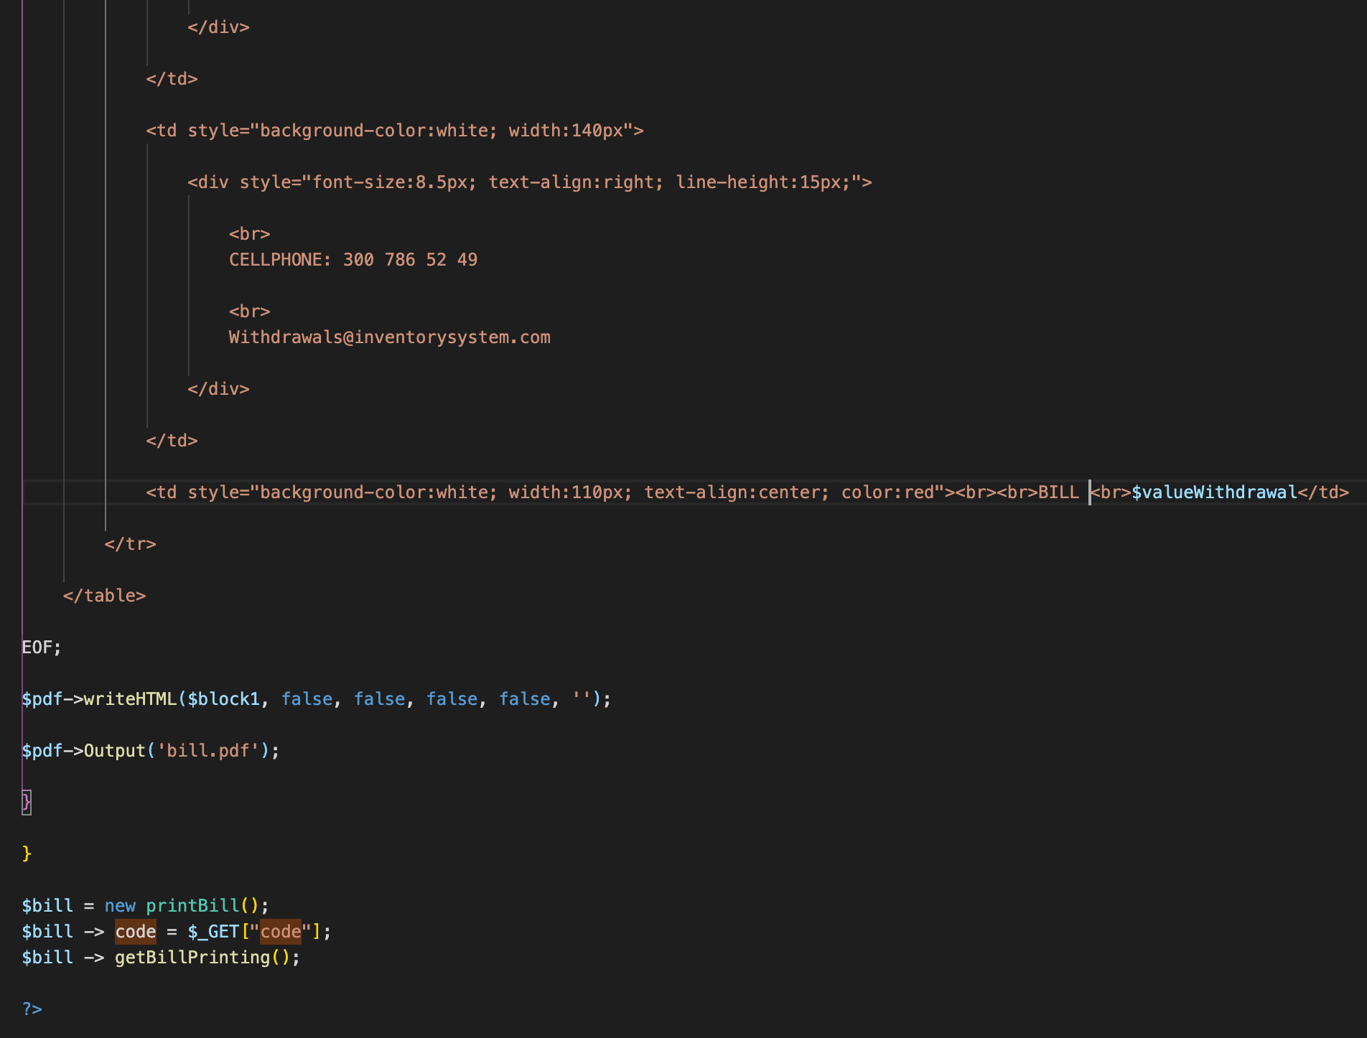

* Link to the controller



And so on…

1. Showing Sales Range

Configure the print button to work in mobile device mode

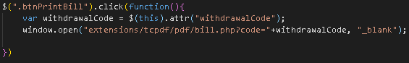

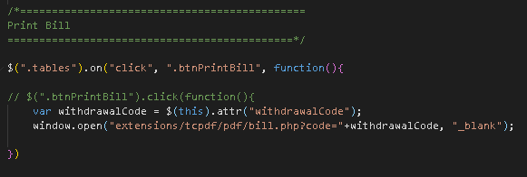

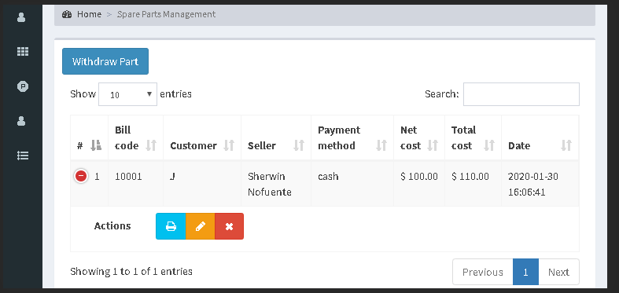

Create the date range button

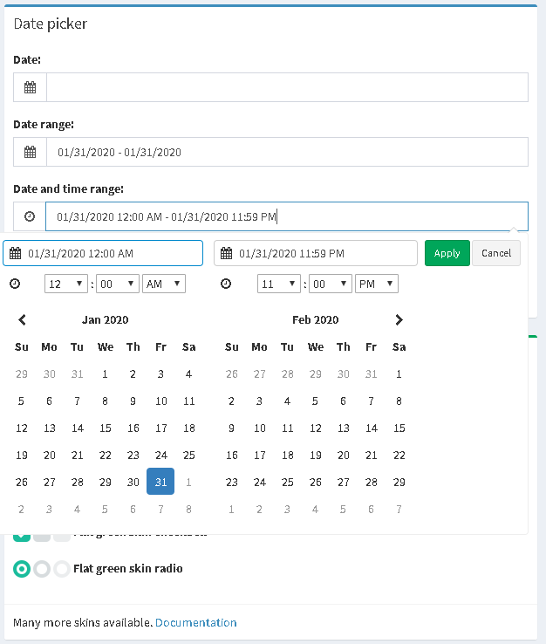

* Add the date range picker plugin @ <https://www.daterangepicker.com/>
* Link it at template.php and ensure it’s in views/bowercomponents/bootstrap-datepicker





* In withdrawn.php, add the date range.

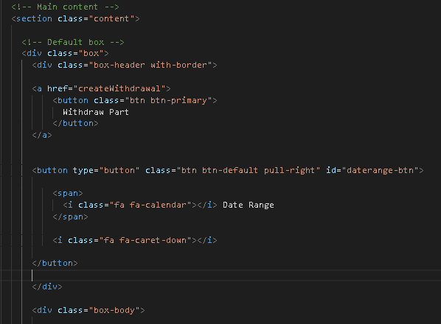

* Apply the js from the admilte.io to withdrawn.js

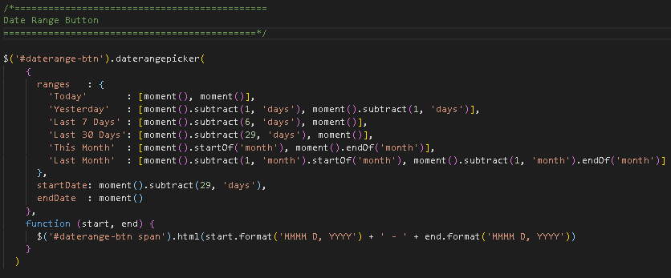

* output

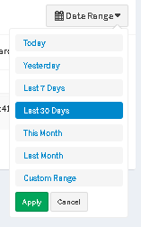

* Link the daterange picker with the db. In withdrawal.js,
* 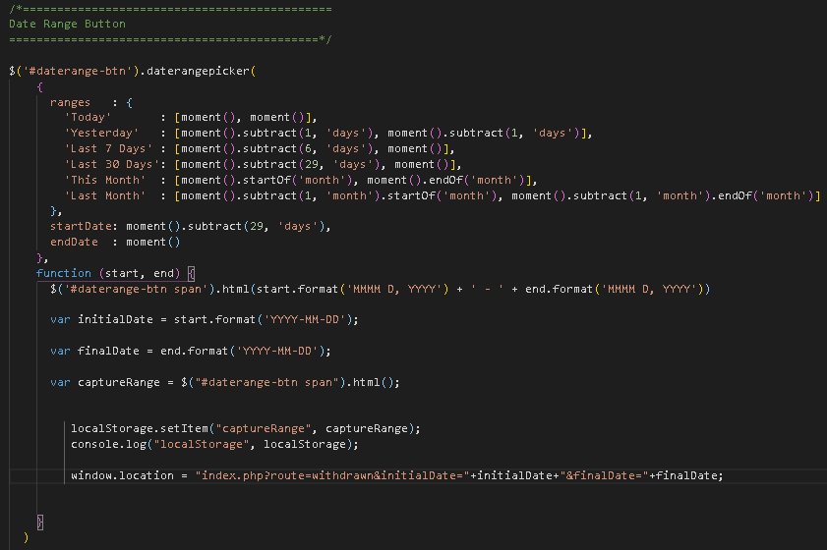
* Cancel date range

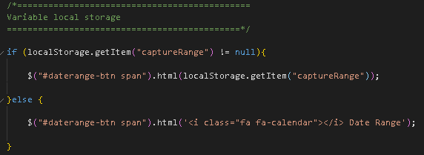

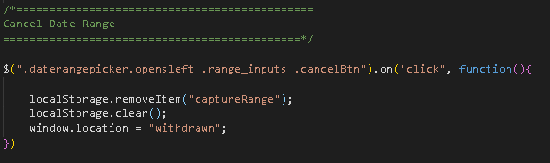

In withdrawal.php,

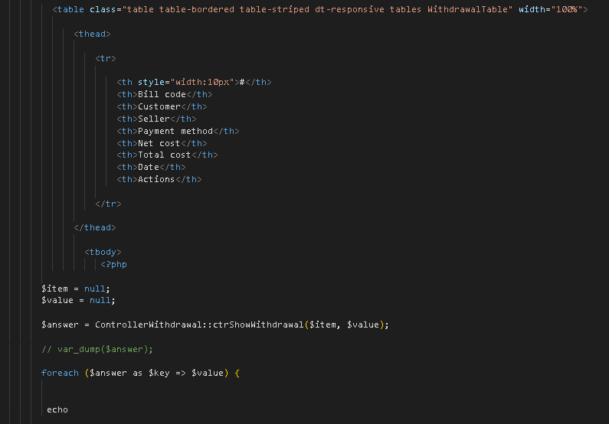

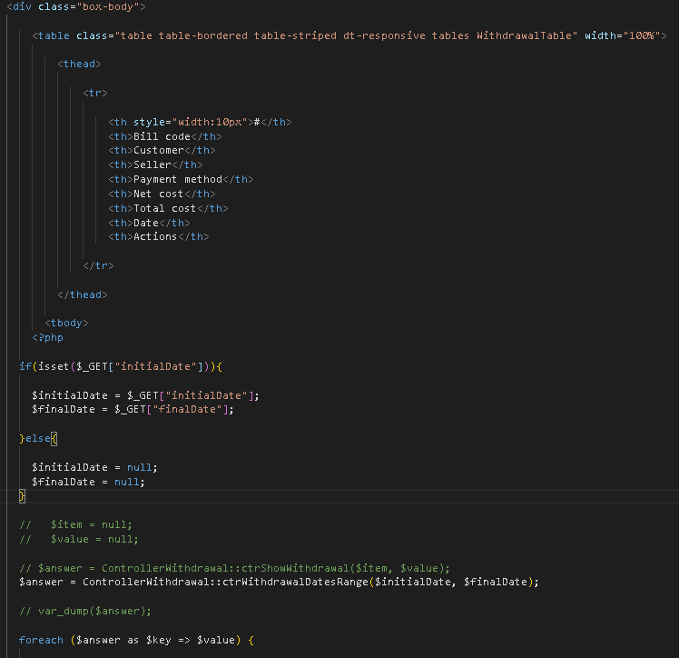

* Create the controller in withdrawal.controller.php
* Create the model for DateRange
* In withdrawal.js

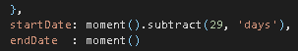 >> 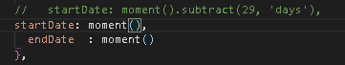

Fix the Today date range picker

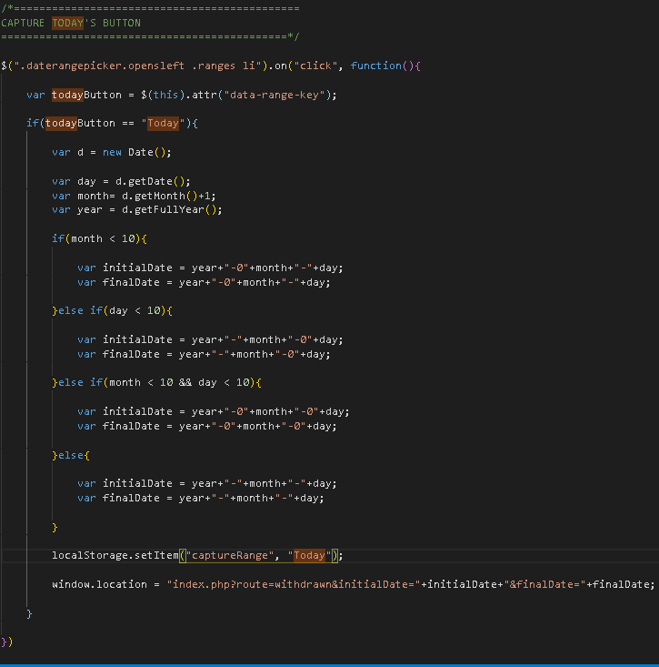

1. Adjusting Sales Ranges

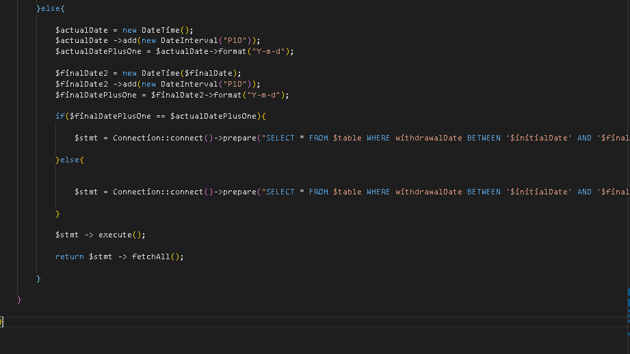

1. Sales Report

* In reports.php, duplicate the code for DateRange picker and named the button class as .daterange-btn2
* Create the reports.js, duplicate the code for DateRange picker js
* Create the reports folder inside the modules folder
* Create the sales-graph.php, pull out all the sales info

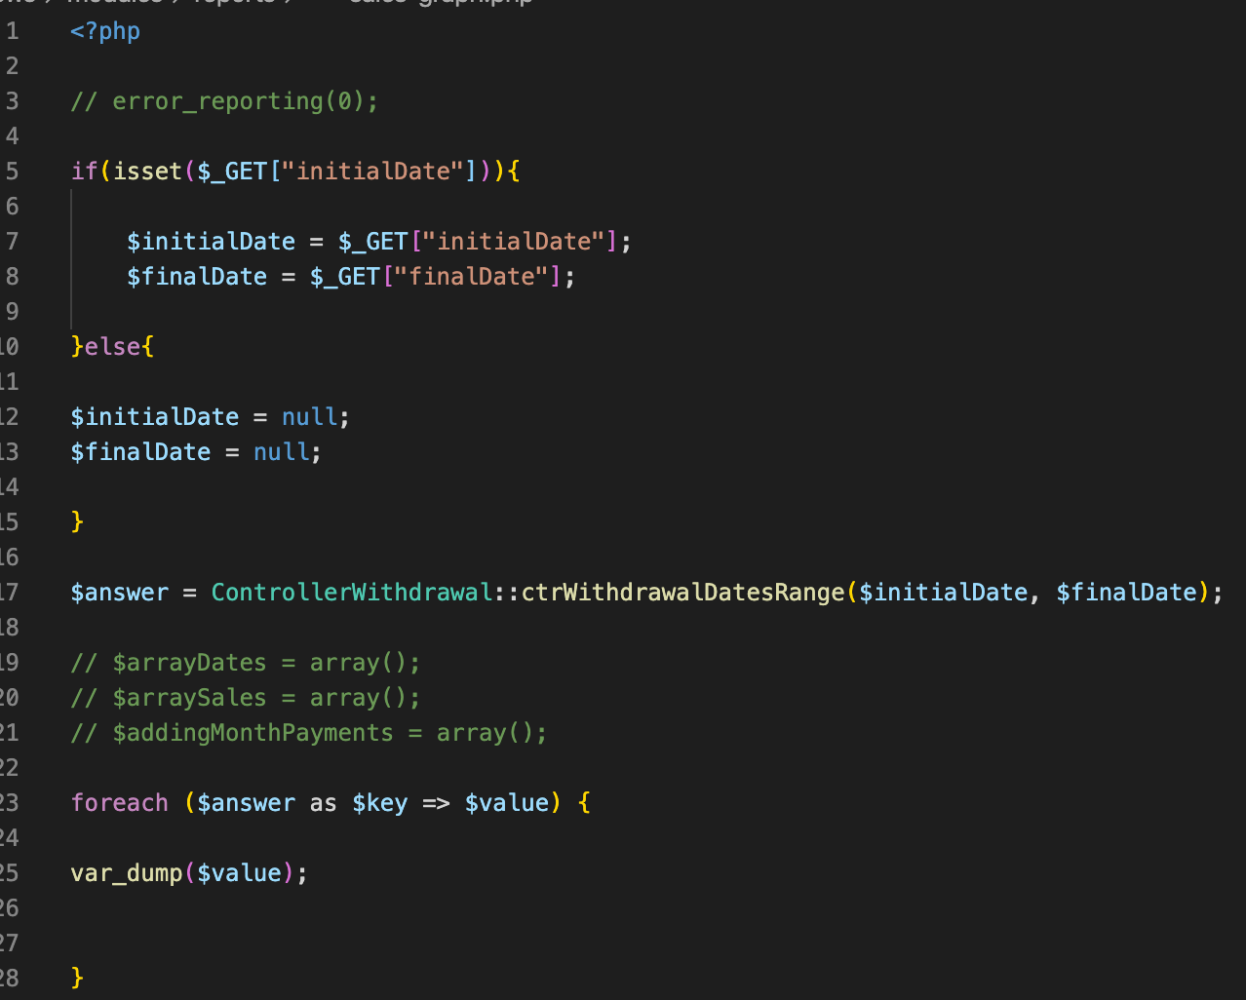

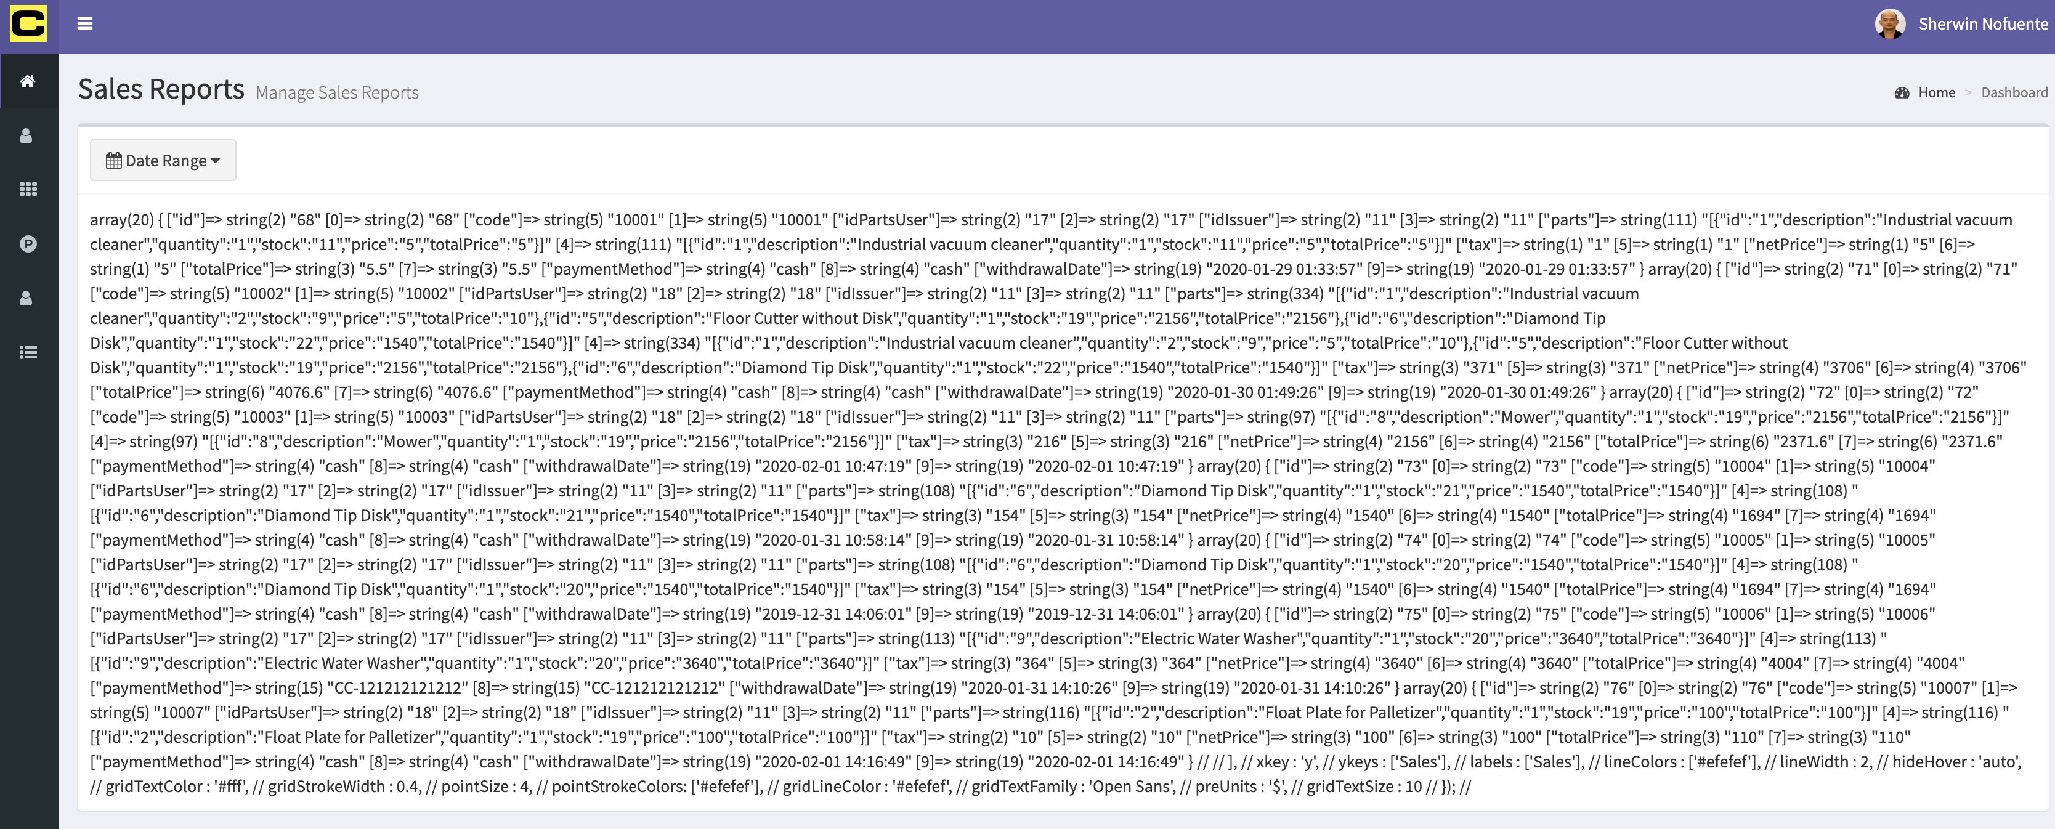

* 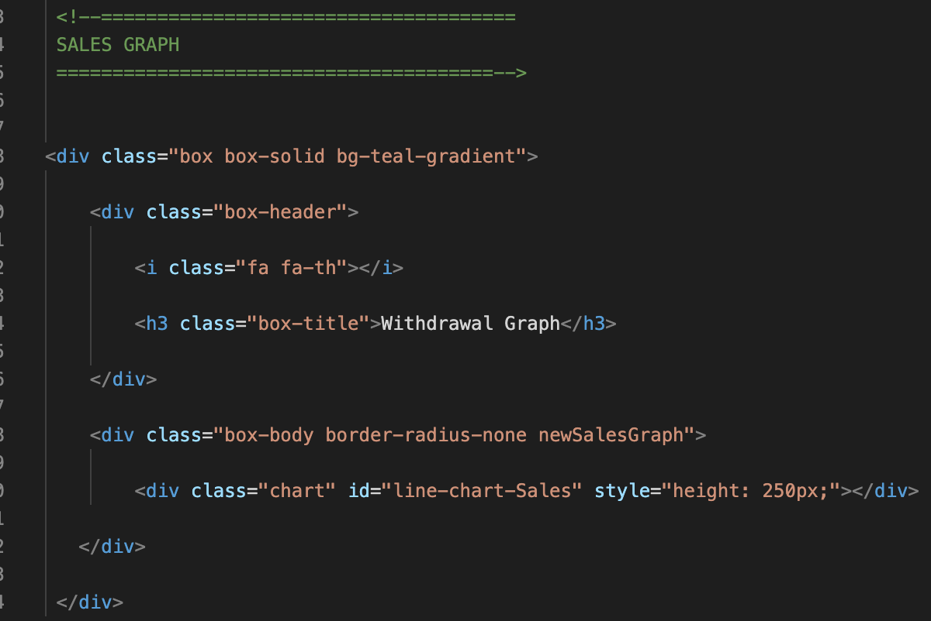Set up the graph section

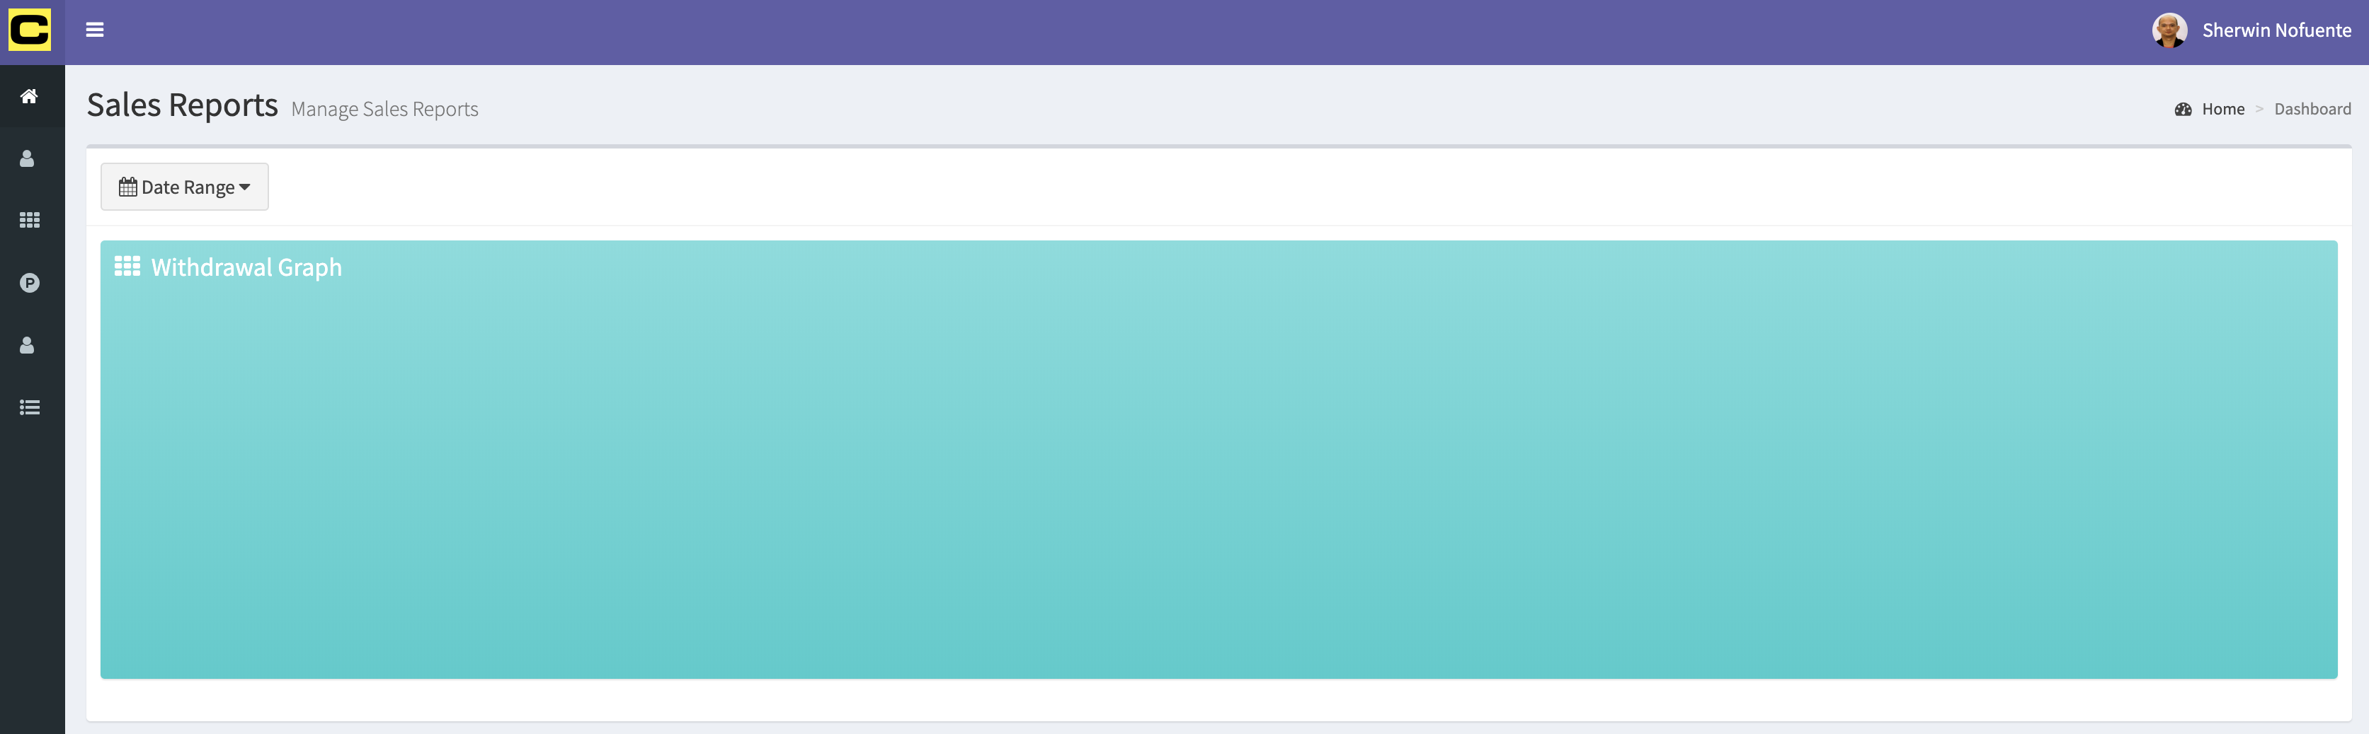

* Link the morris js and css plugin @ “<https://morrisjs.github.io/morris.js/>” in template.php

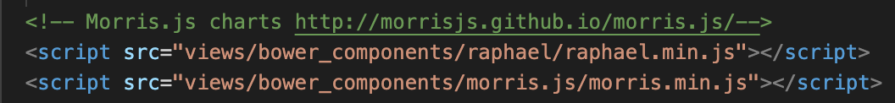

* Get the line-chart reference from dashboard.js. use the ctrWithdrawalDatesRange to pull out the data from db.

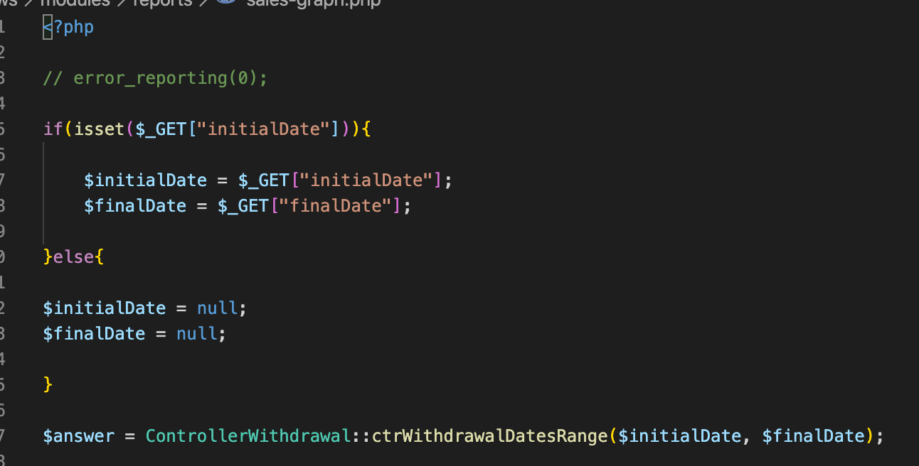

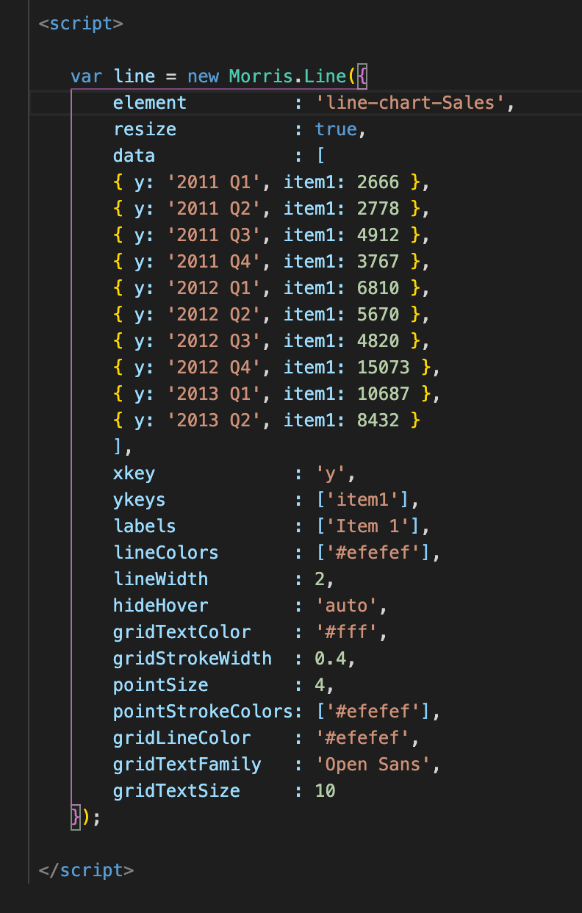

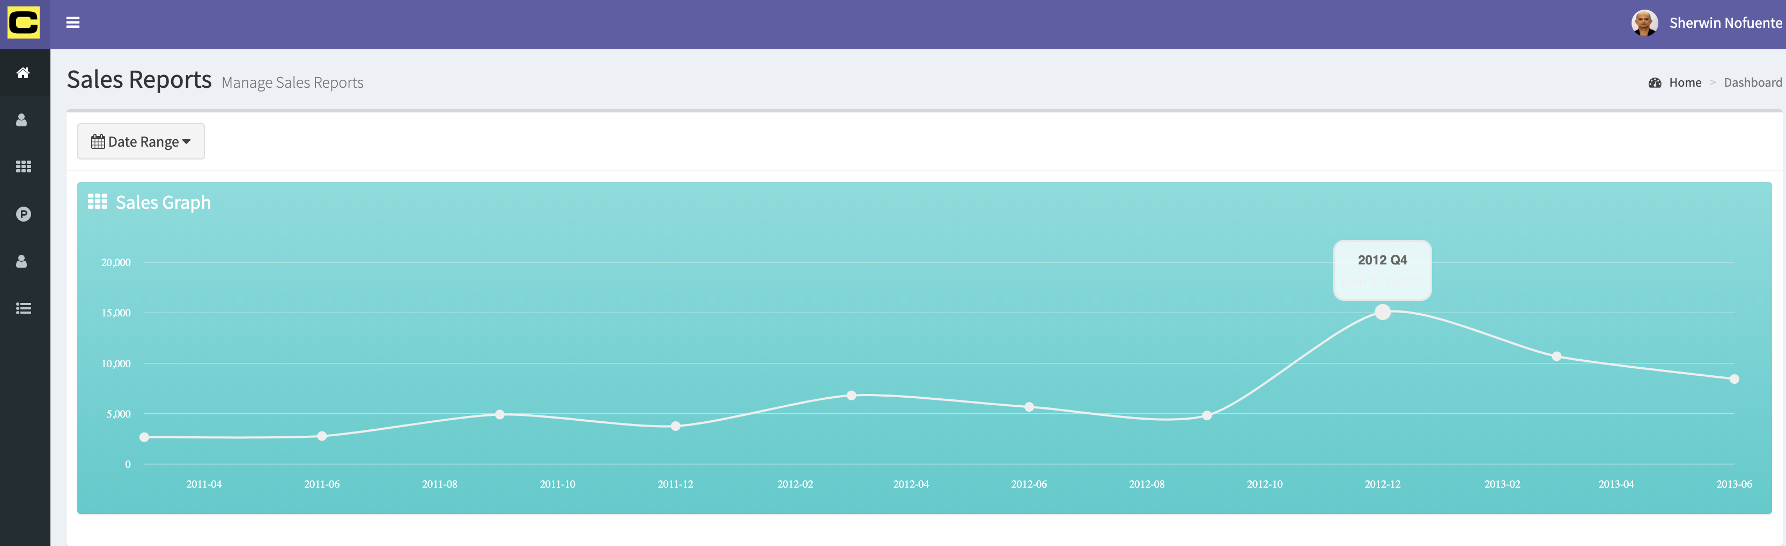

Fix the white background of the label. Change the color to balck in morris.css

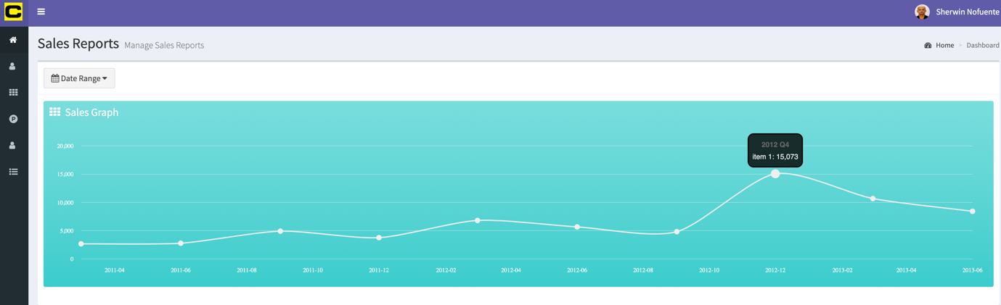

1. Sales Report – Part 2, make the graph dynamic

* Remove the Qs in the year of the static data reference. This will serve as the X key Y keys will be the value from withdrawals. preUnits put $ in each tooltip.
* Capture the year and months in from db

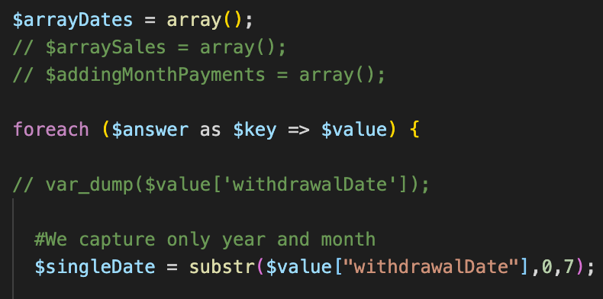

0 = start of the string

7 = number of digits

= 2020.01

0 = 2

7 = 2020.01 characters

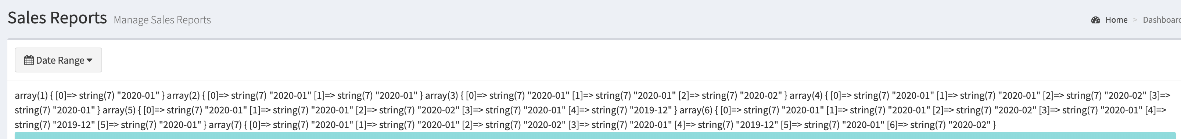

Put the year and months into the js. Create a php tag and enclose a foreach of the arrayDates and use the syntax from the ctr. Echo the value of the json and use the format of “y” inside the JSON. Change the Year value by the JSON data of “.$value.”.

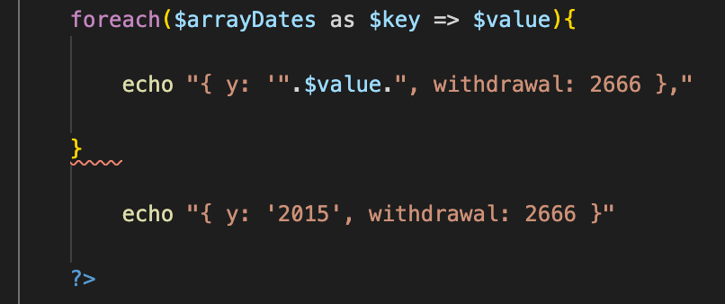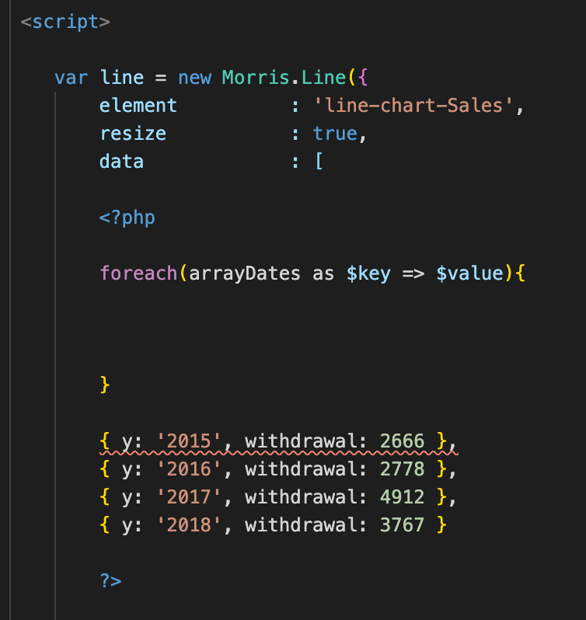

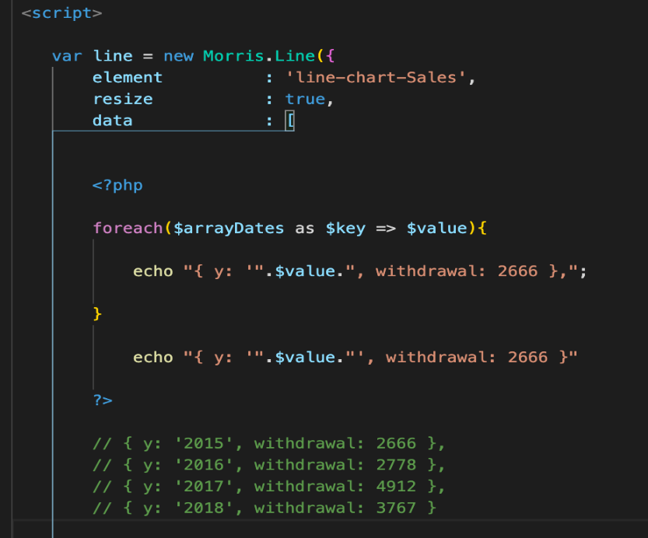

It displays the date of sales

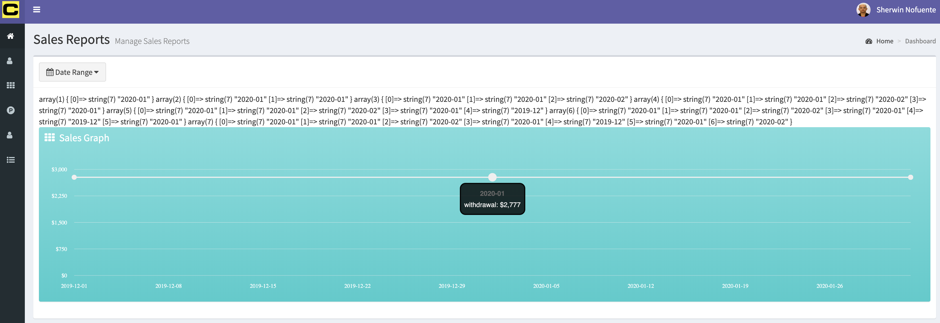

* Capture the total sales per month. Create the $arraySales

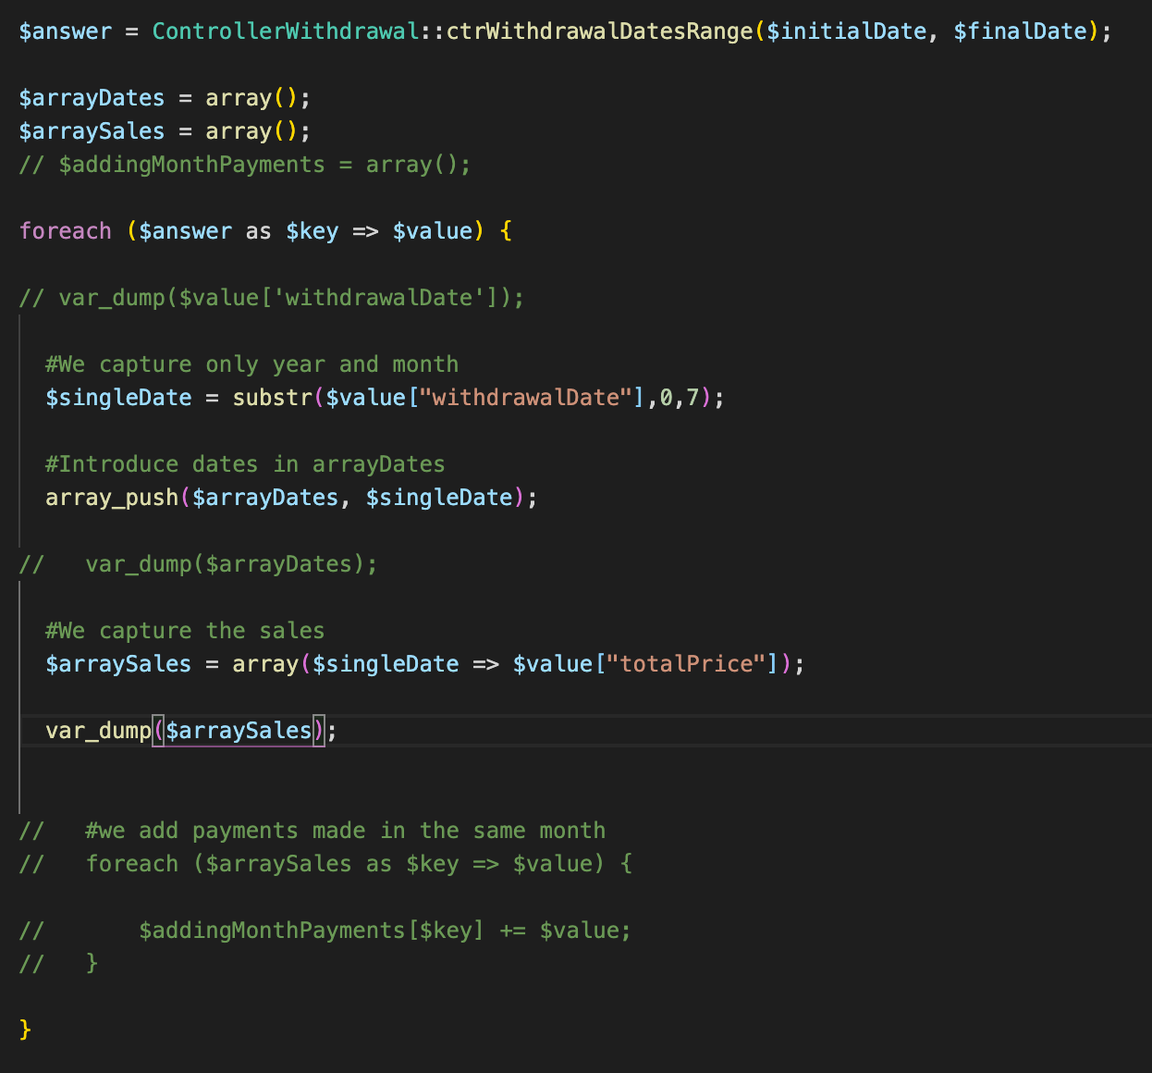

It can capture now the total sales per month

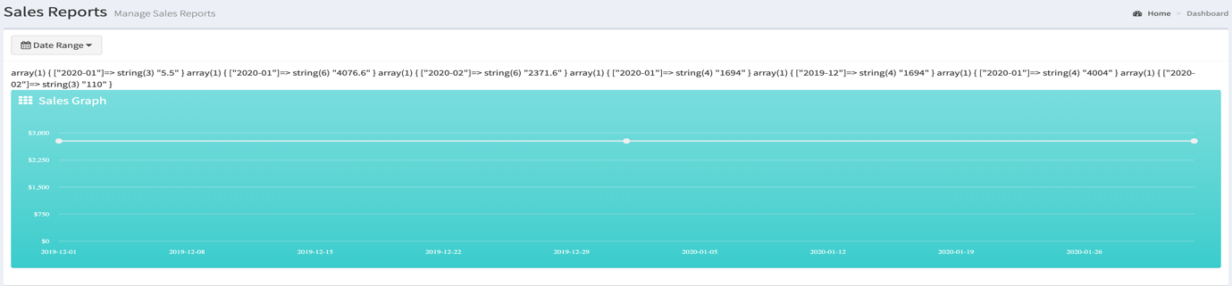

* Create the forEach for the $arraySales and store it in the variable $addingMonthPayments[$key] += value, += value will add the totalSales value per date

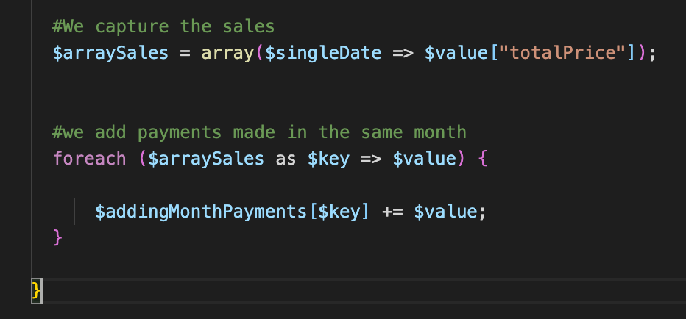

This will create an error as the variable should be put into array

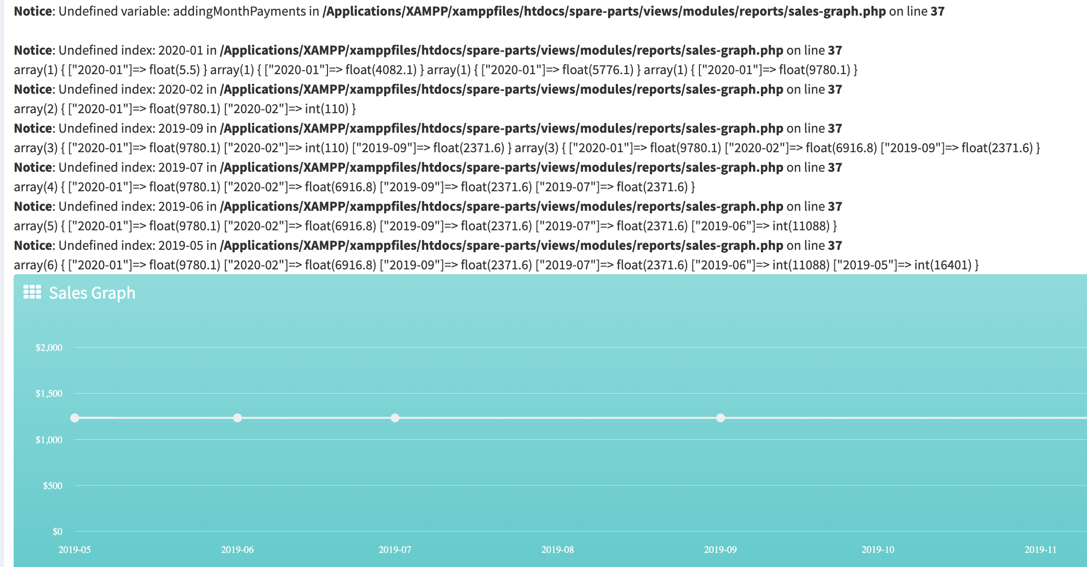

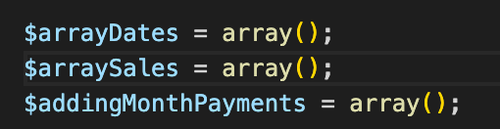

This will create another error as the date can’t be an index. Index should be 1, 2 ,3 4, 5… Add the error reporting as below

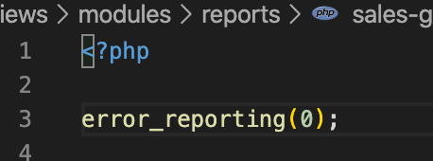

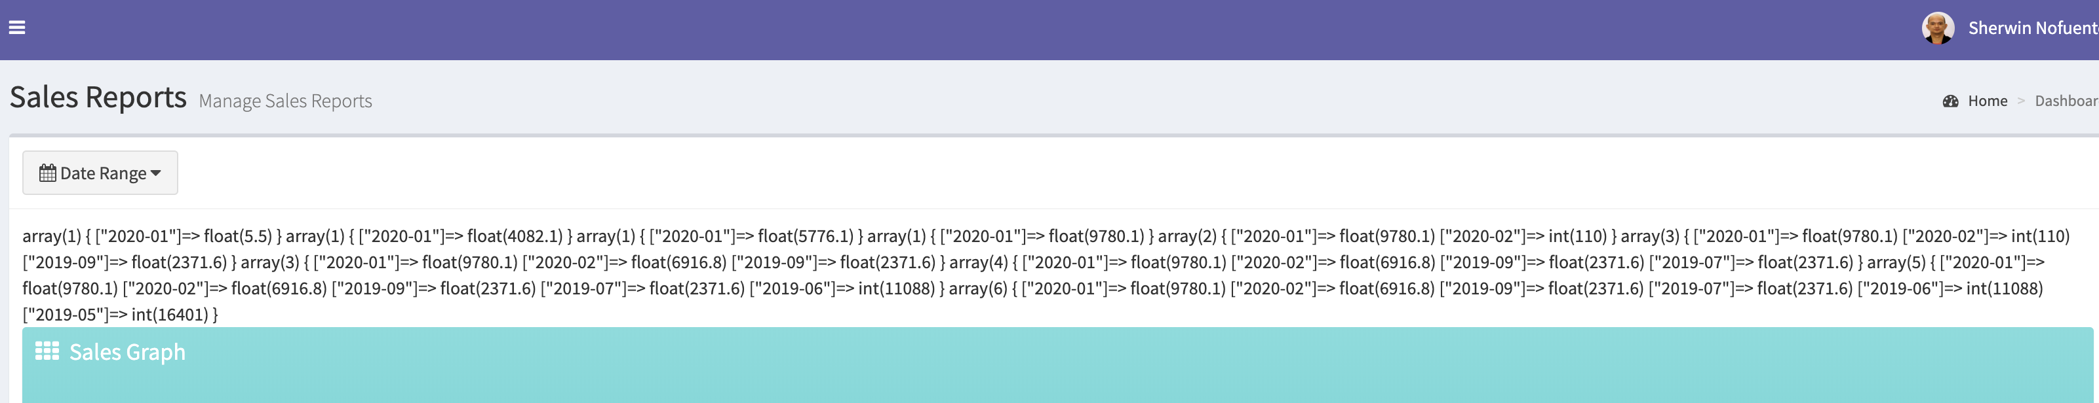

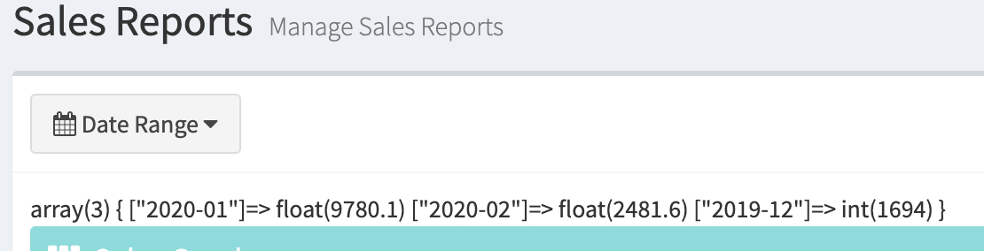

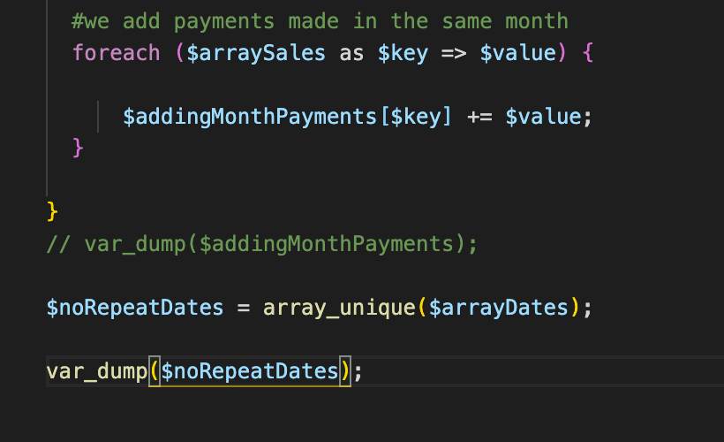

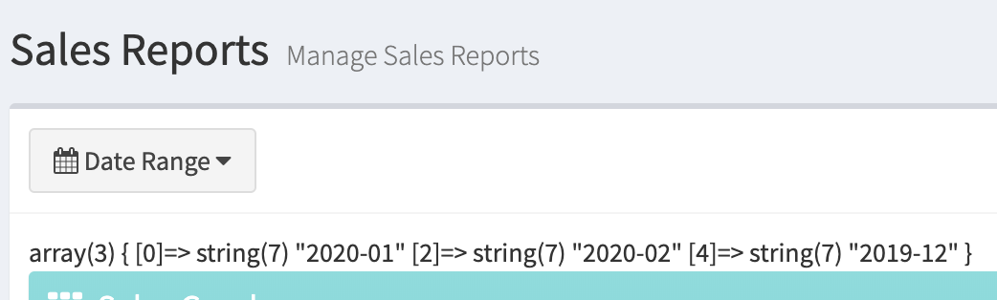

* Check if the addingMonthsPayment is same as the $arrayDates, this method can’t be use.

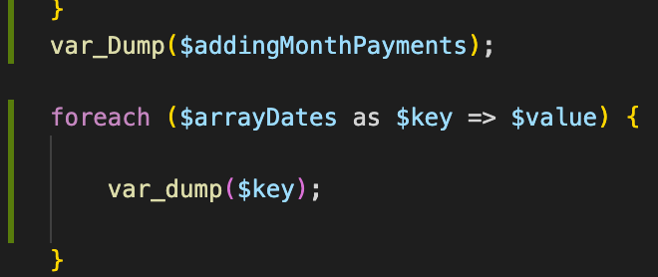

Use $noRepeatDates = array_unique($arrayDates)

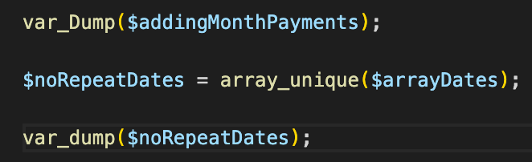

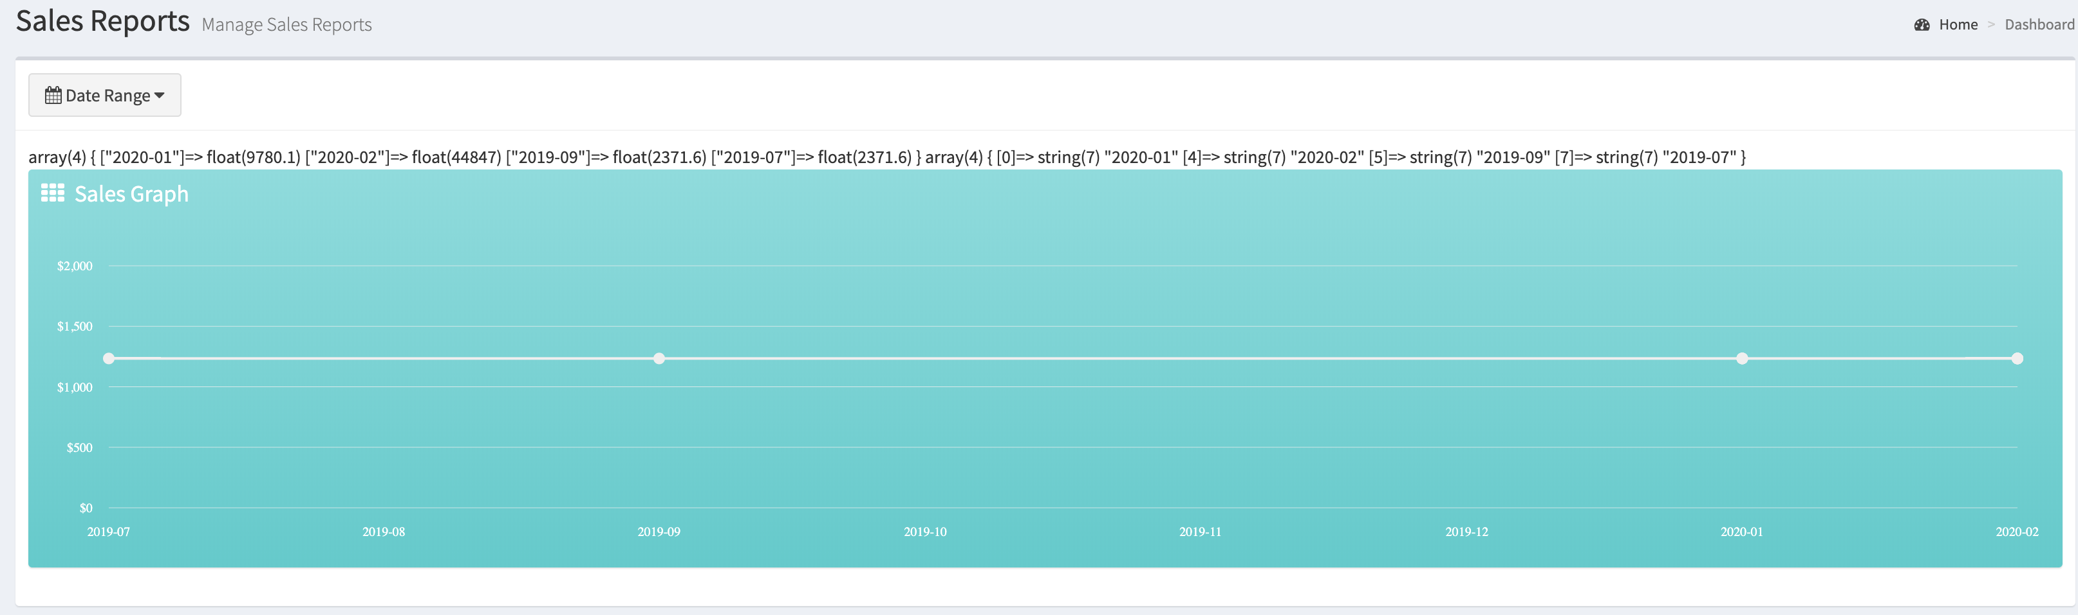

Assign in the foreach of the html the $noRepeatDates and as the totalSales value

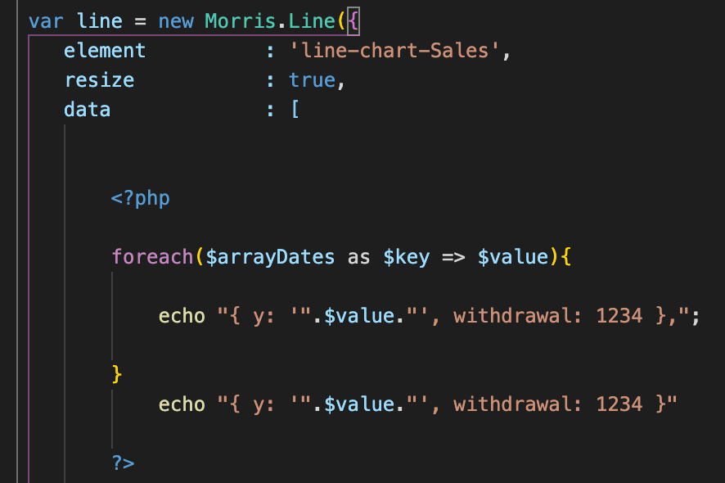 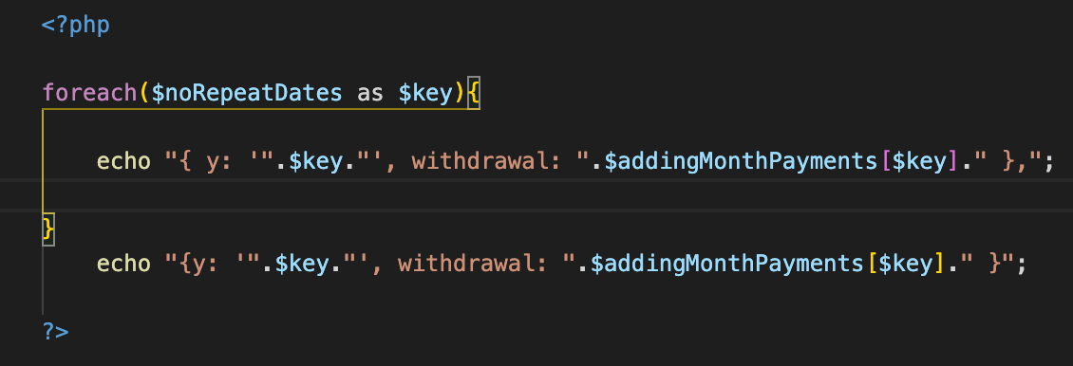

* It now displays the correct month and totalSales per month

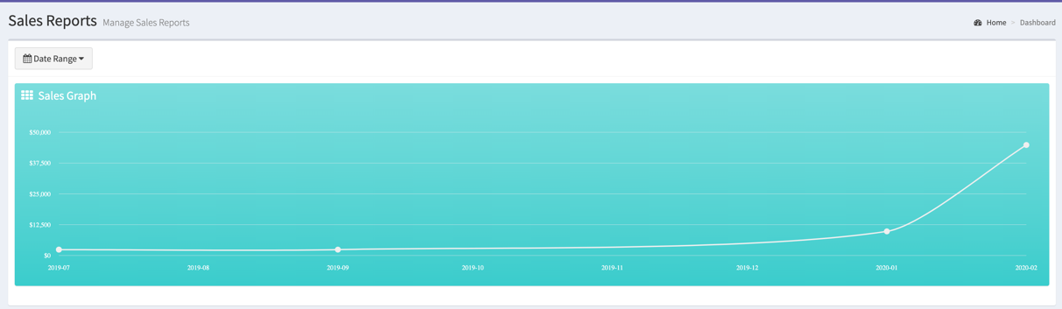

1. Sales Report – Part 3

* Work on the best seller parts, use the donut chart
* Copy the source html code from adminlte.io to bestseller-products.php and define it in the reports.js

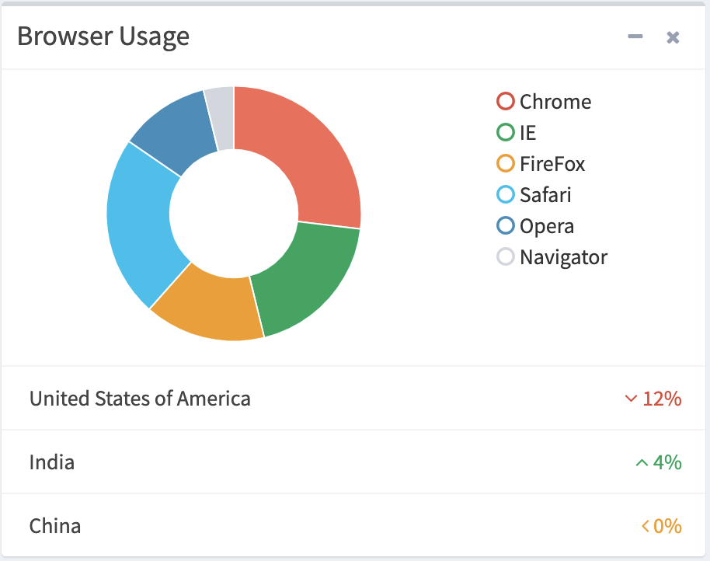 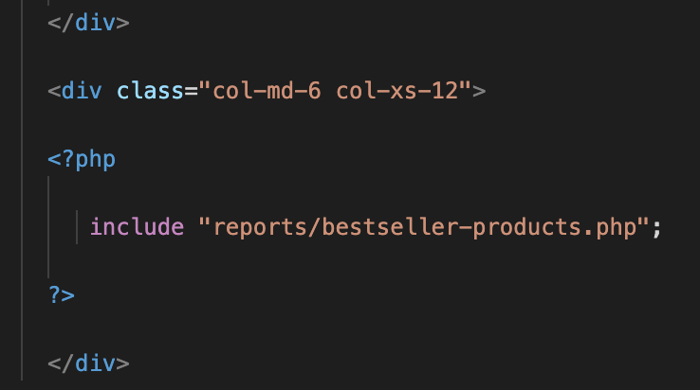

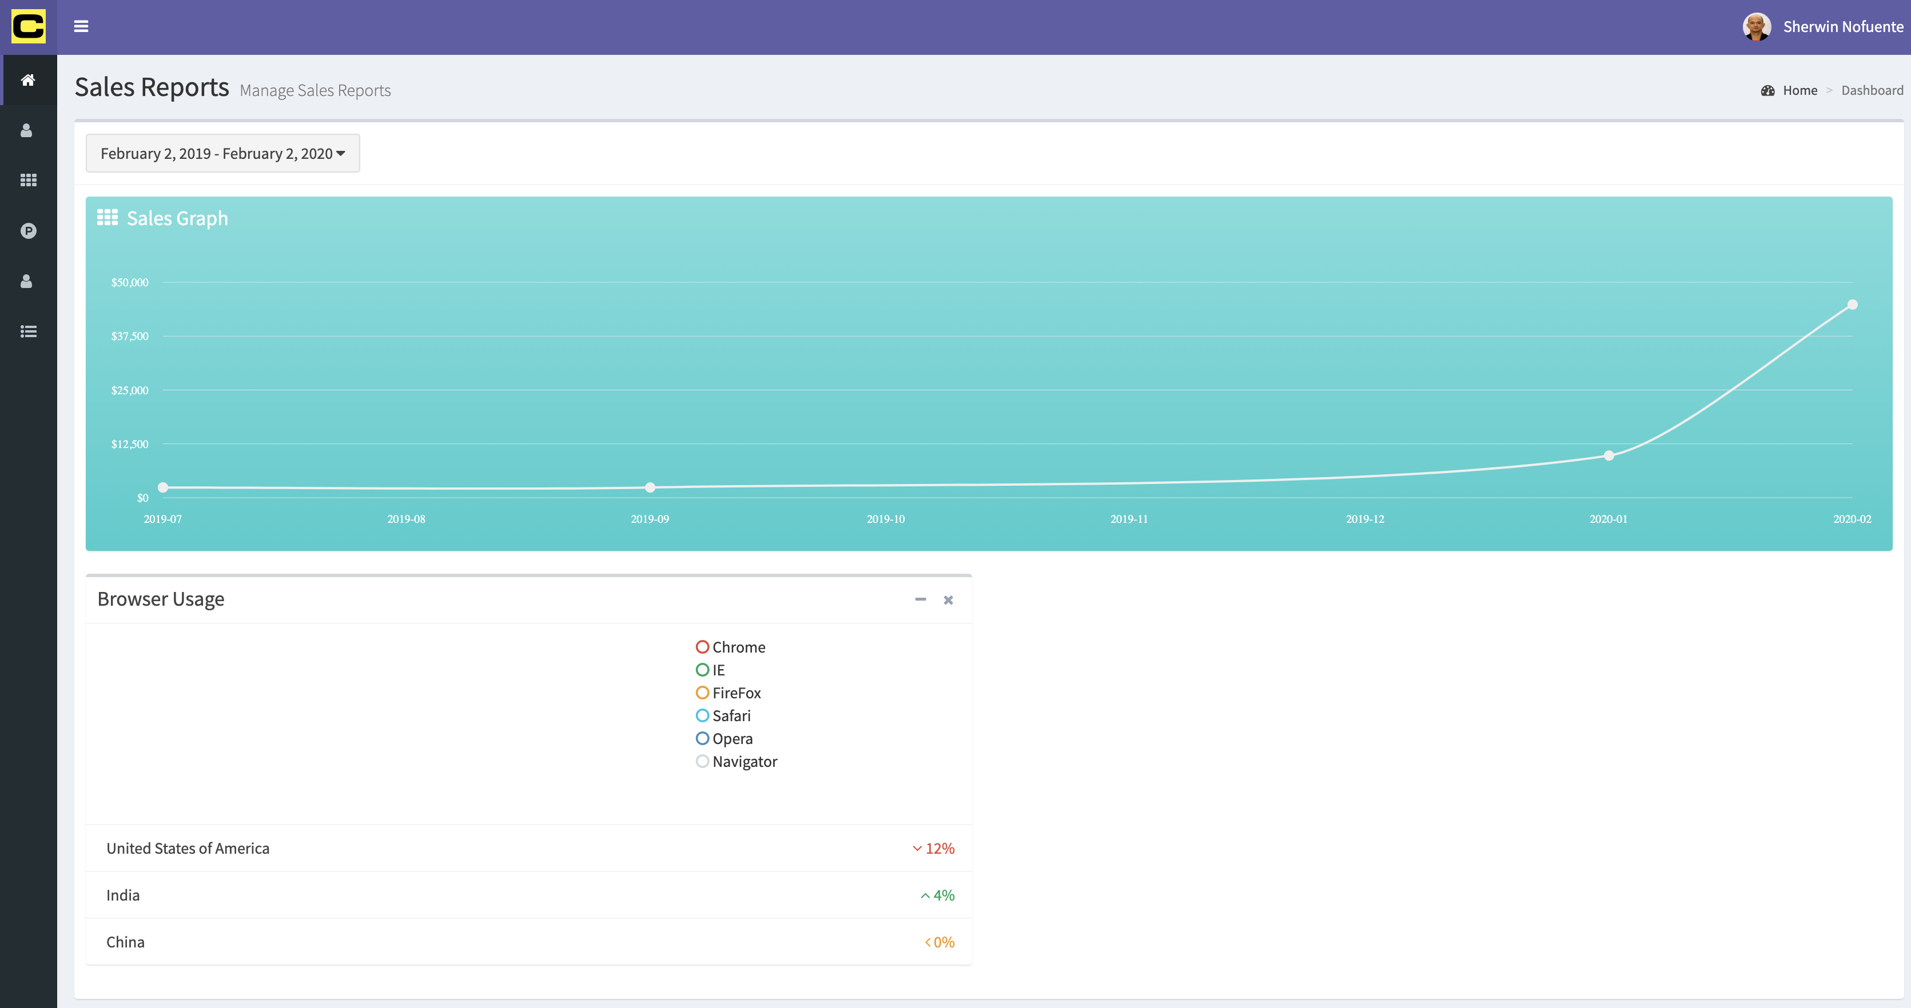

* Add the chart.js in template.php. copy the js from dashboard.js and put it in the bestseller-products.php



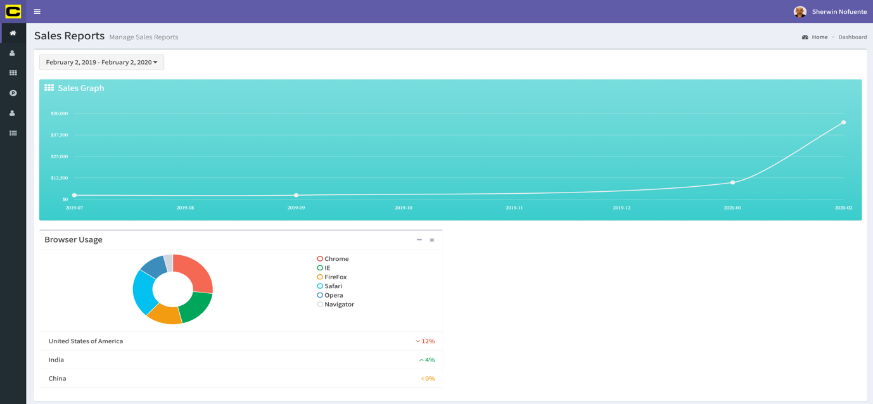

* Make the chart dynamic. Open a php tag and define the controller to show the parts. In table parts of the db, sales will be the reference

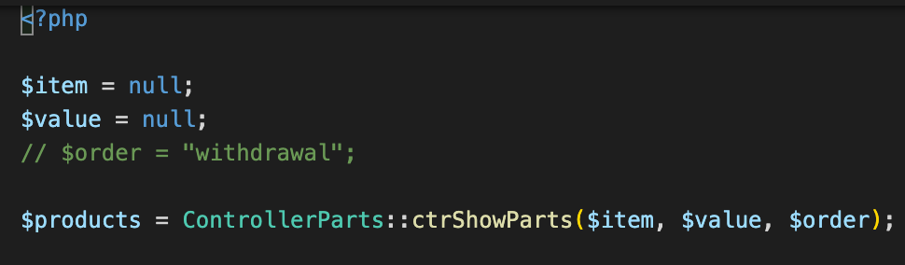

* Revise the parts.model to include the sales and arrange it in descending order

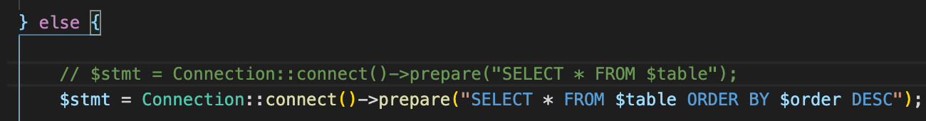

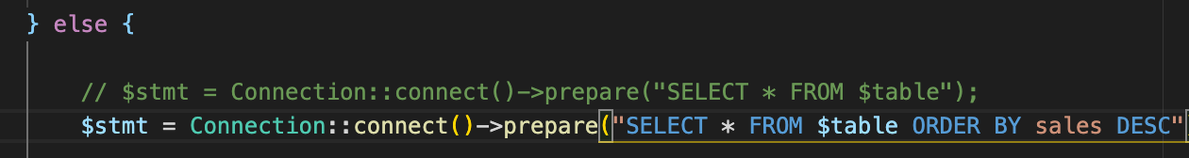

* Createthe $order = “id” and pass it as parameter to all the php files using the ctrShowParts. Sample below is from datatable-parts.php. to find all the files using ctrShopwParts = command + shift + F.

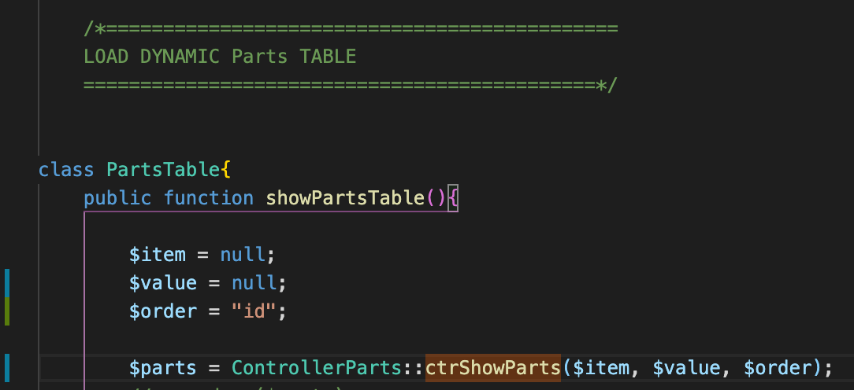

This will now sort the most number of withdrawal. At this point the Air Extractor and the Illumination Tower tops the withdrawal

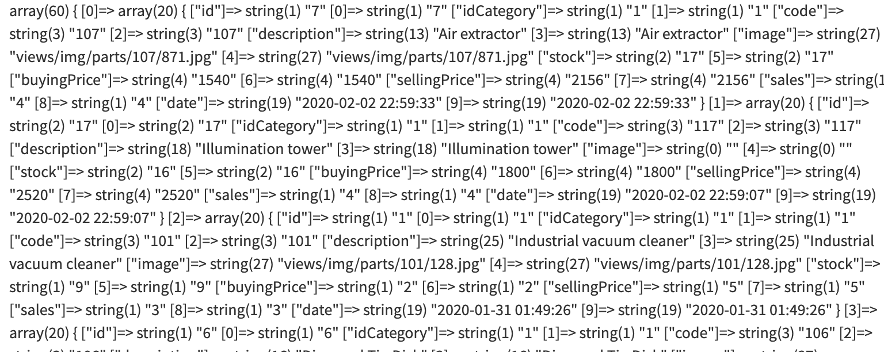

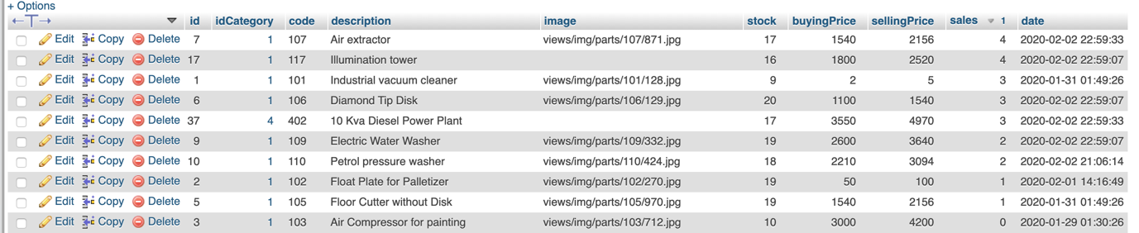

* Open a php tag in the bs-p.php.

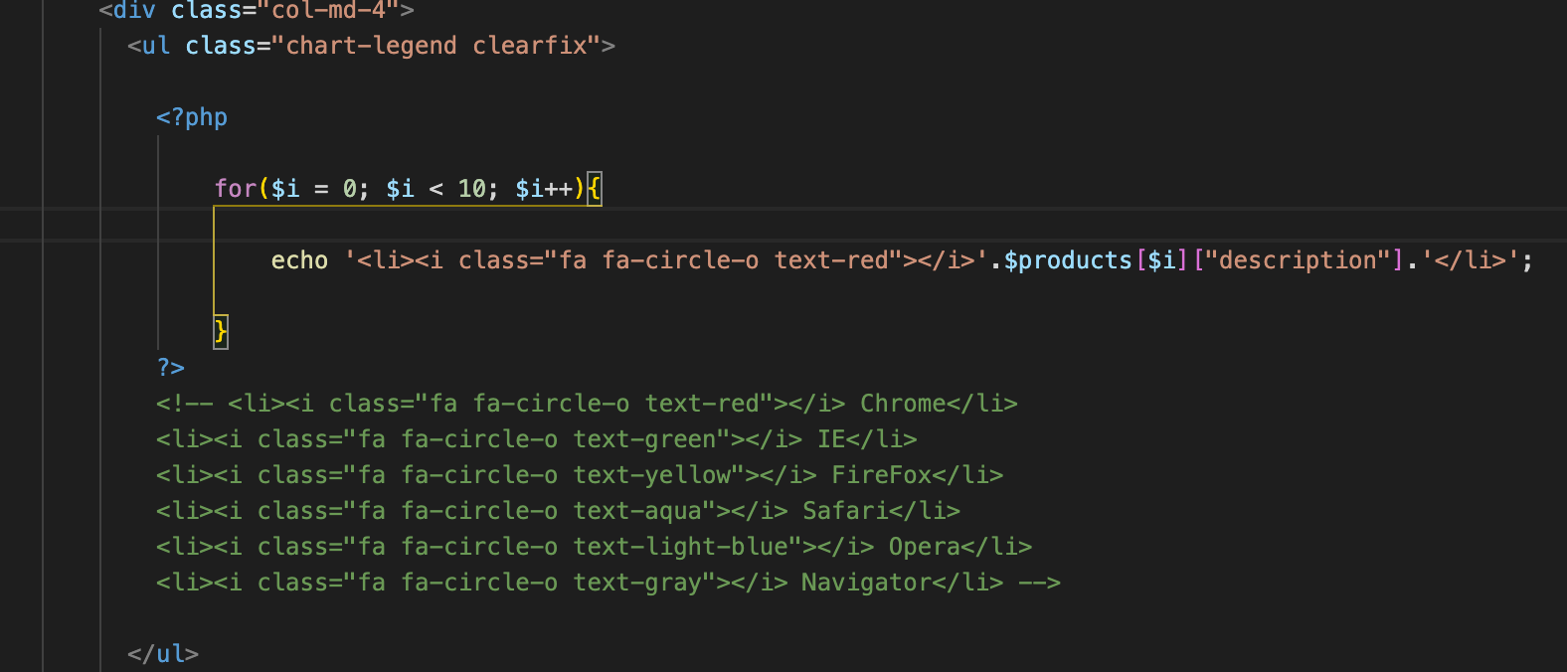

It will now display the top parts

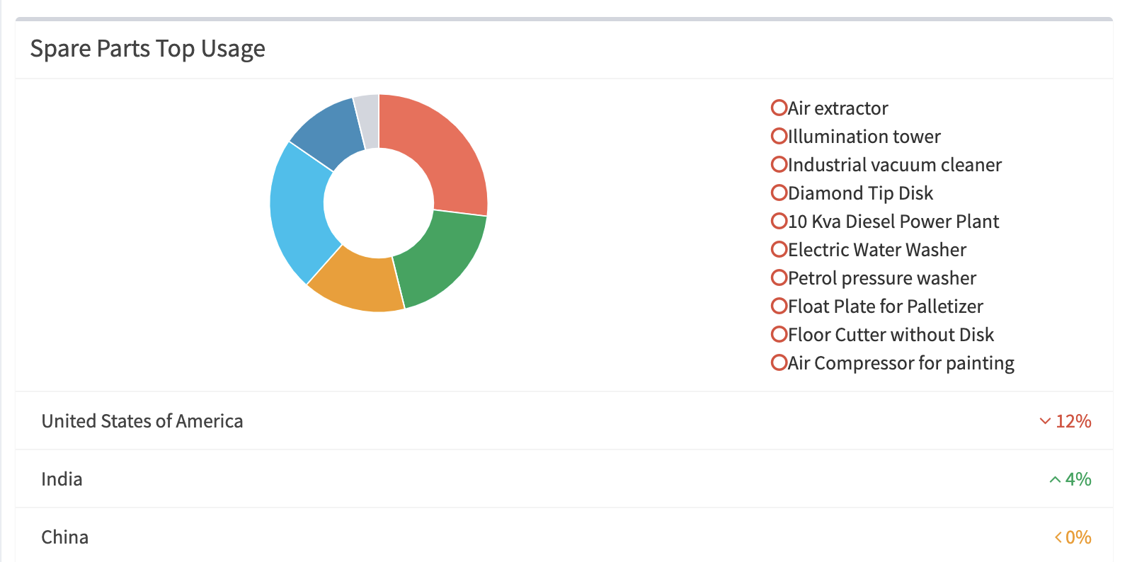

Work out on the colours of the circle. Assign a set of colours



Then assign it inside the php

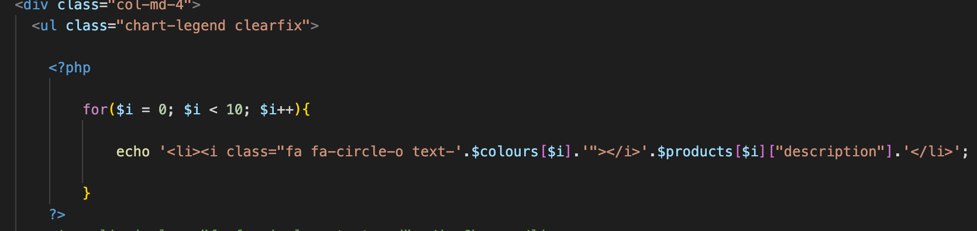

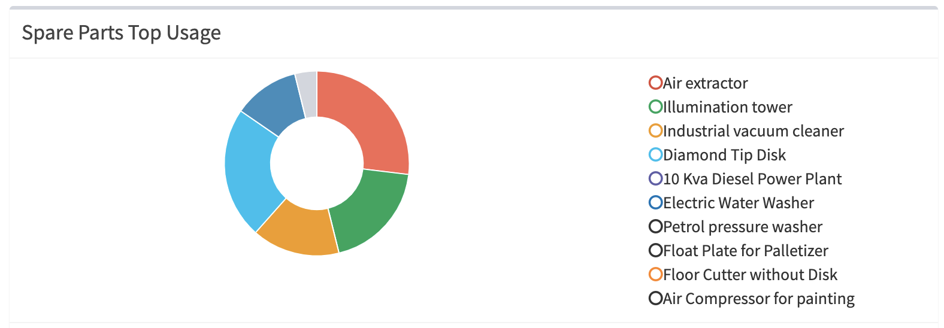

* Work on the % part

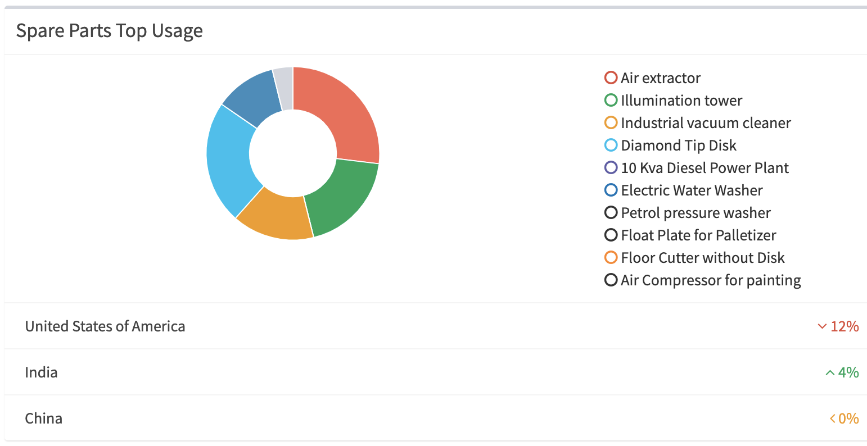

* Open a php tag under stacked. Work on the “United States” and “12%”

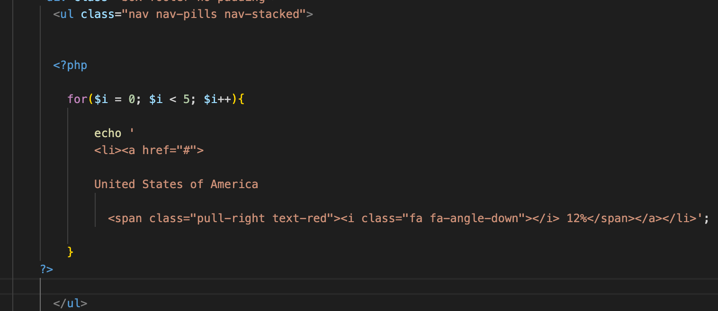 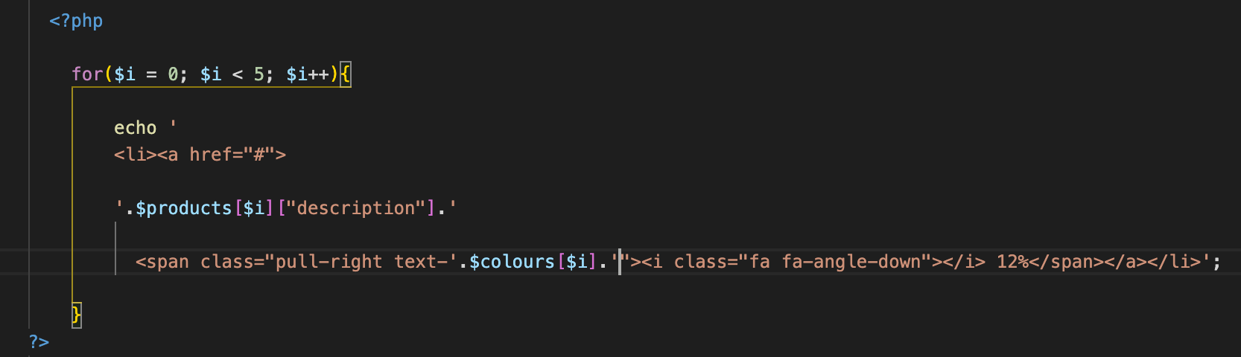

Create a method name showAddingOfTheSales in the parts.controller and define the model mdlshowAddingOfTheSales

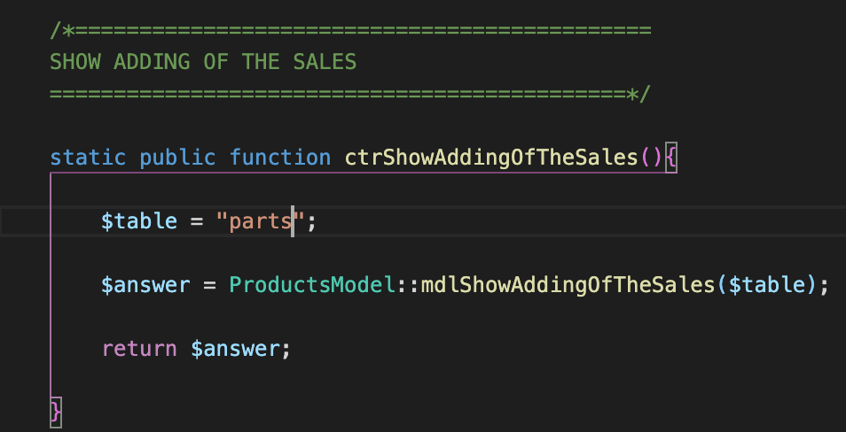 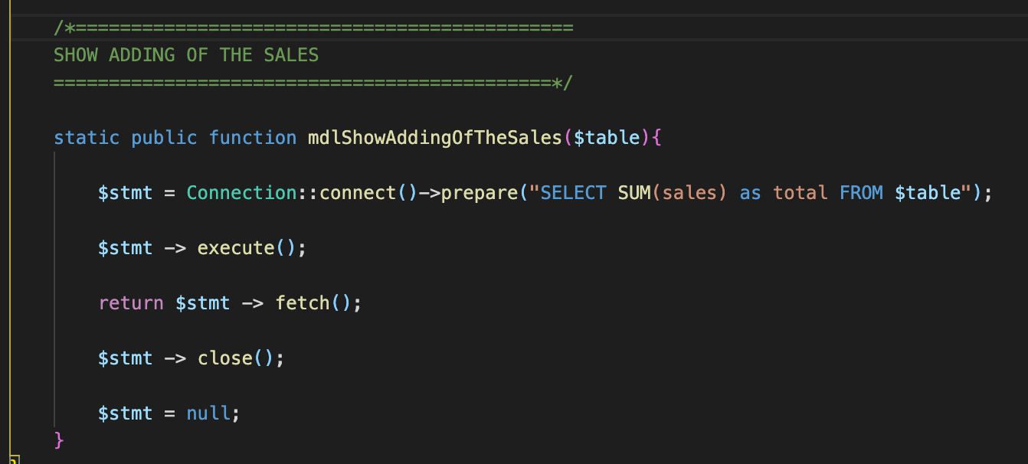

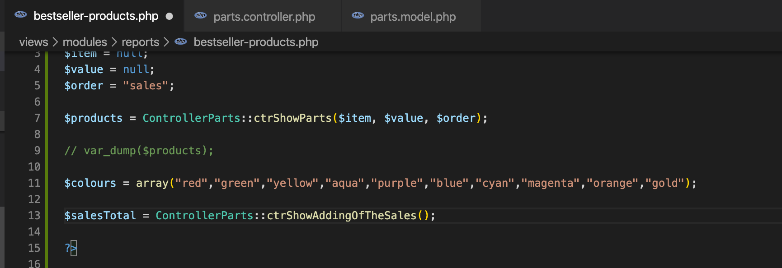

Then change the value of 12% to dynamic



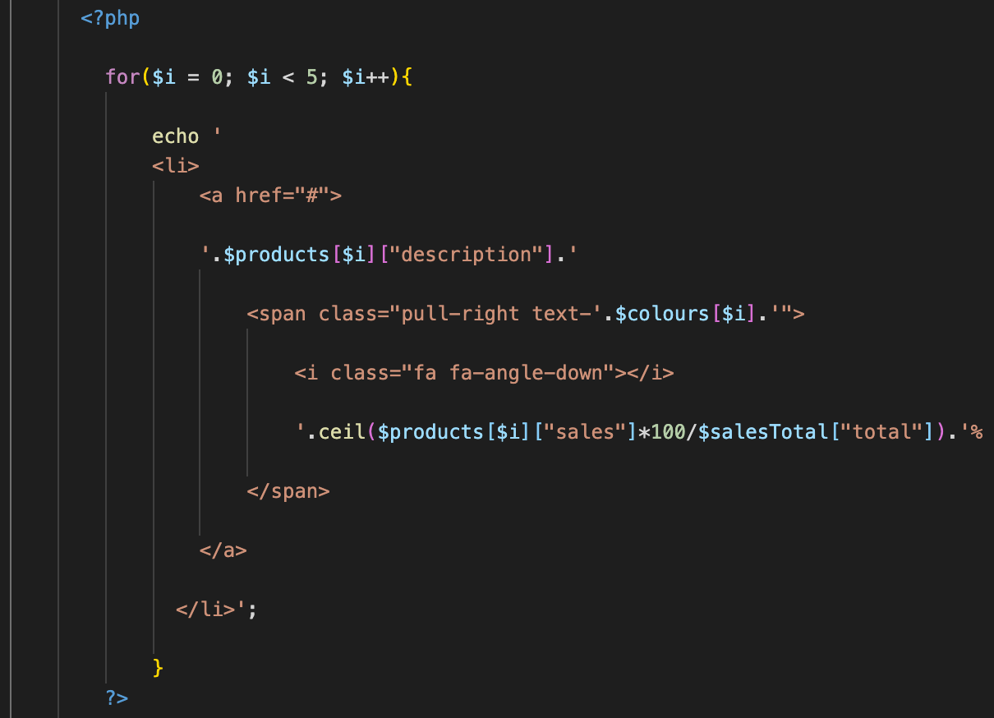

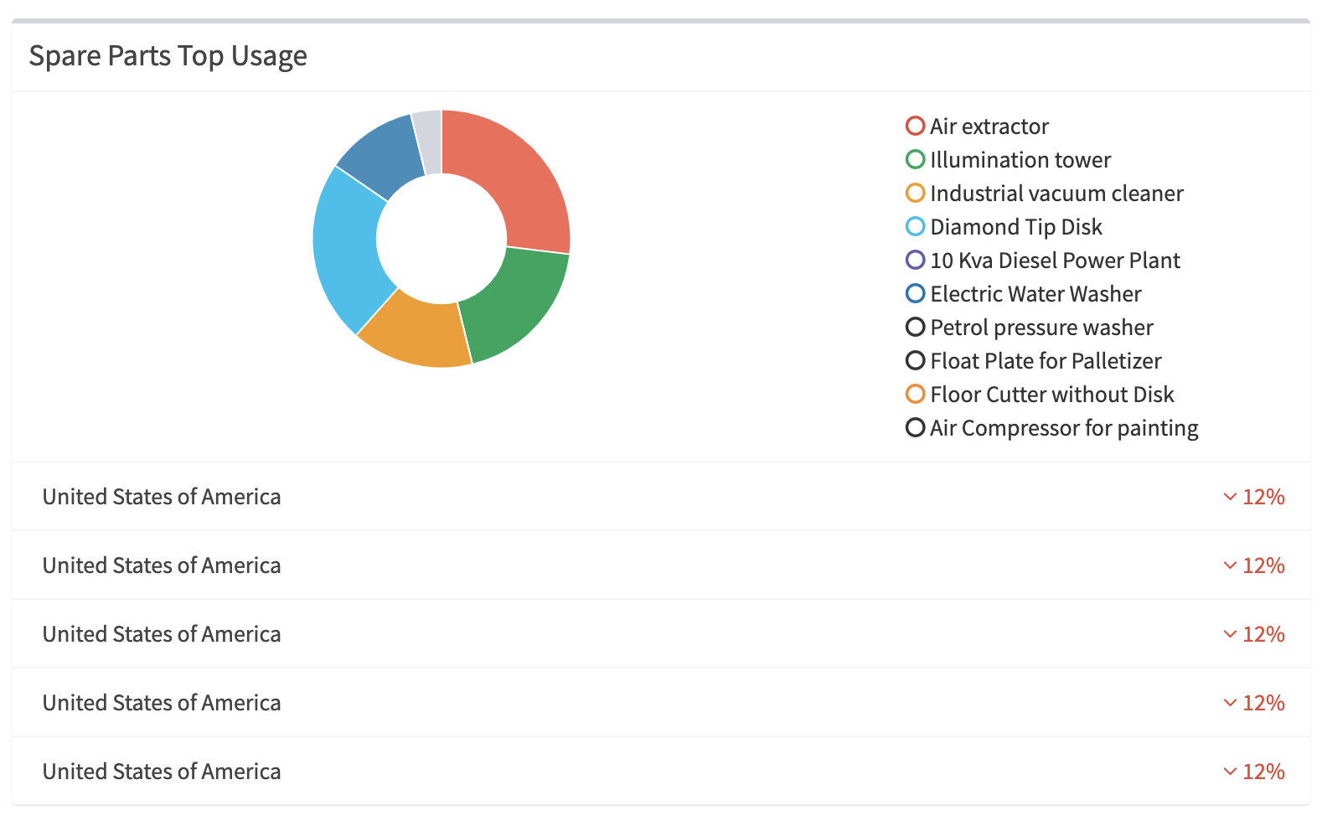 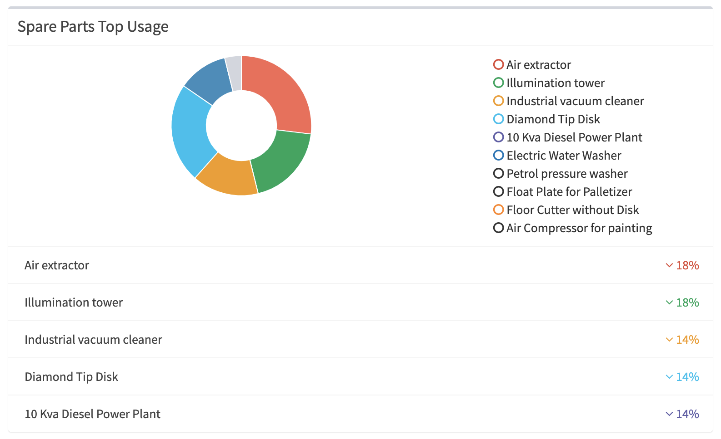

* Put it now in pie chart. In the pie chart option of the php file,

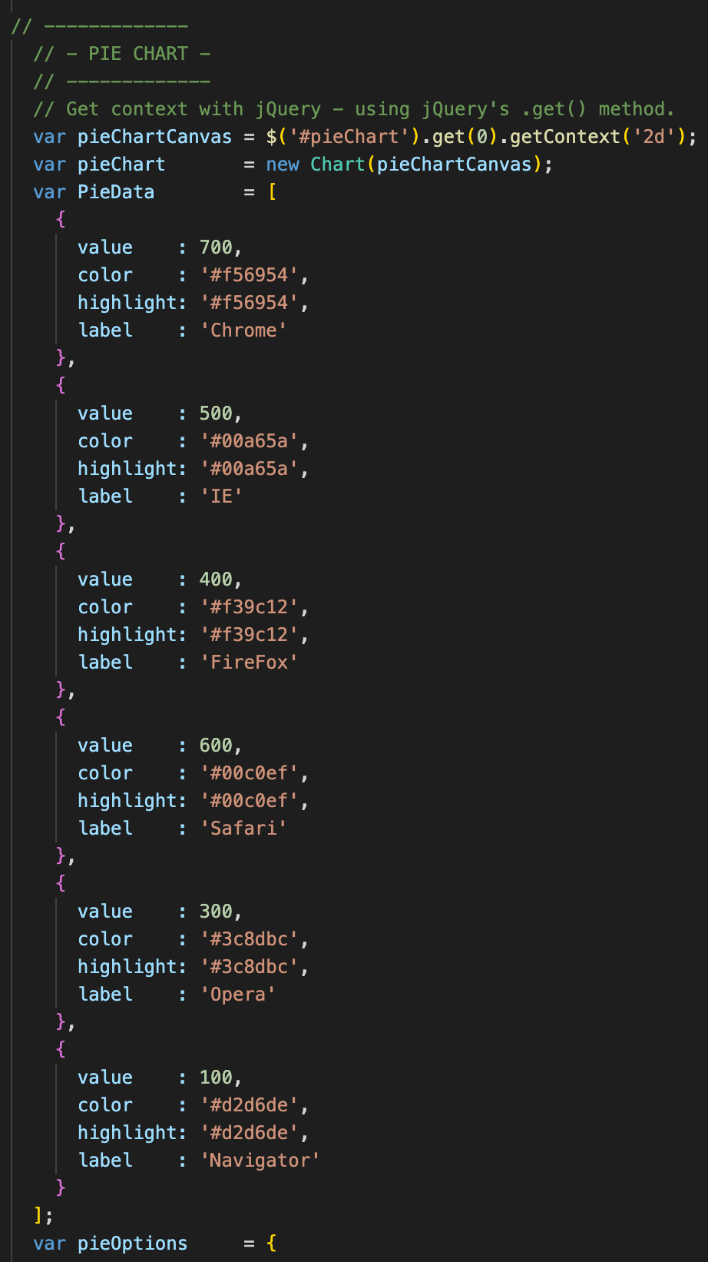 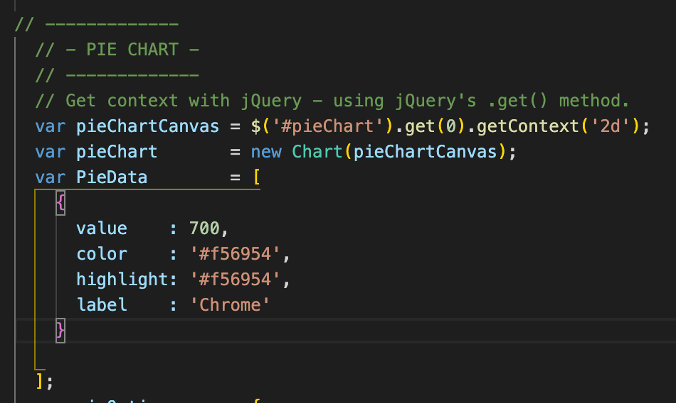

Open a php tag

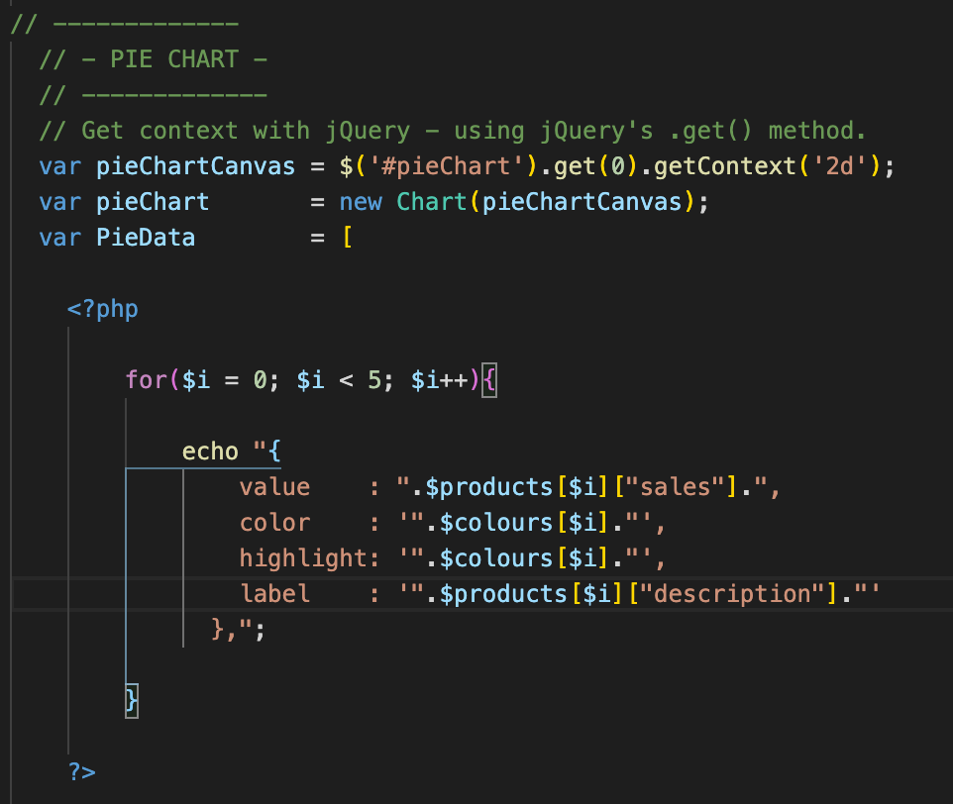 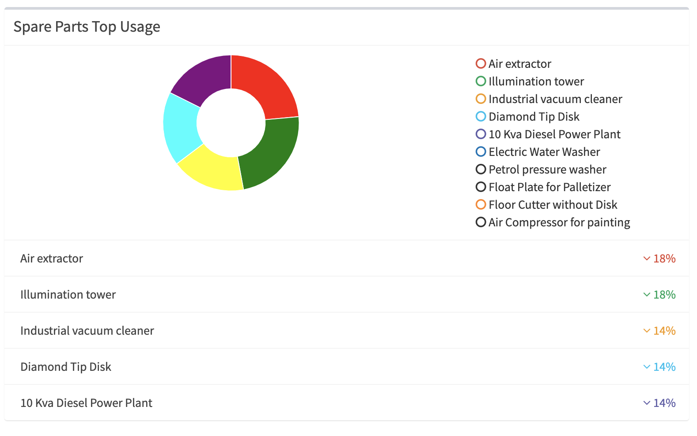

1. Sales Parts Report – Part 4

* Add the div for the issuers graph in the reports.php. Create the issuers.php,

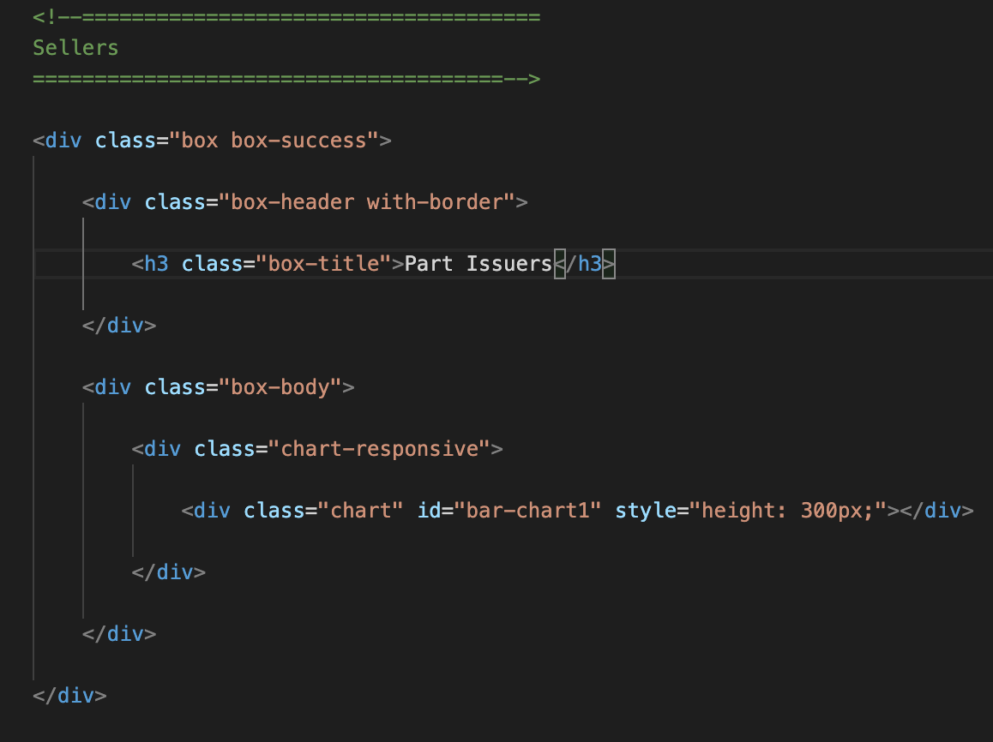

Copy the javascript from the adminlte.io and paste in the issuers.php under <script>

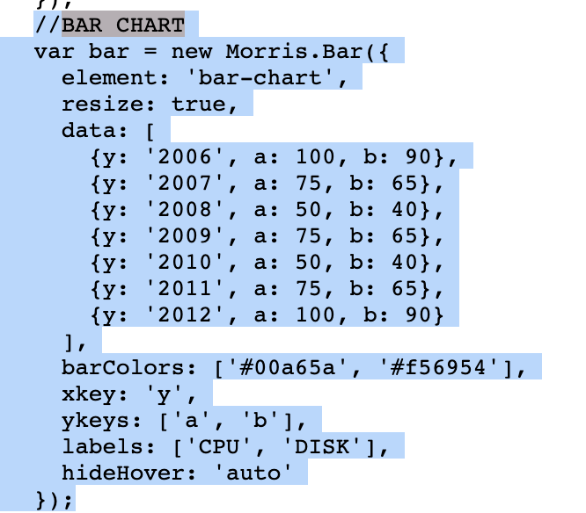 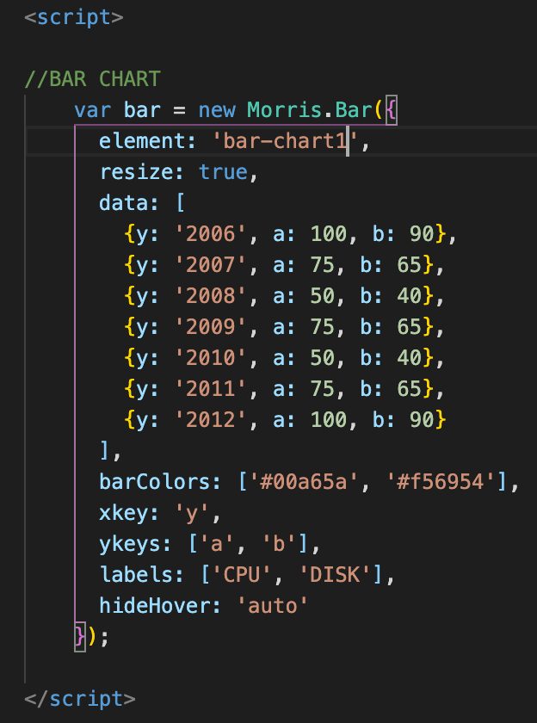

Duplicate it and use it as the graph for partsUser

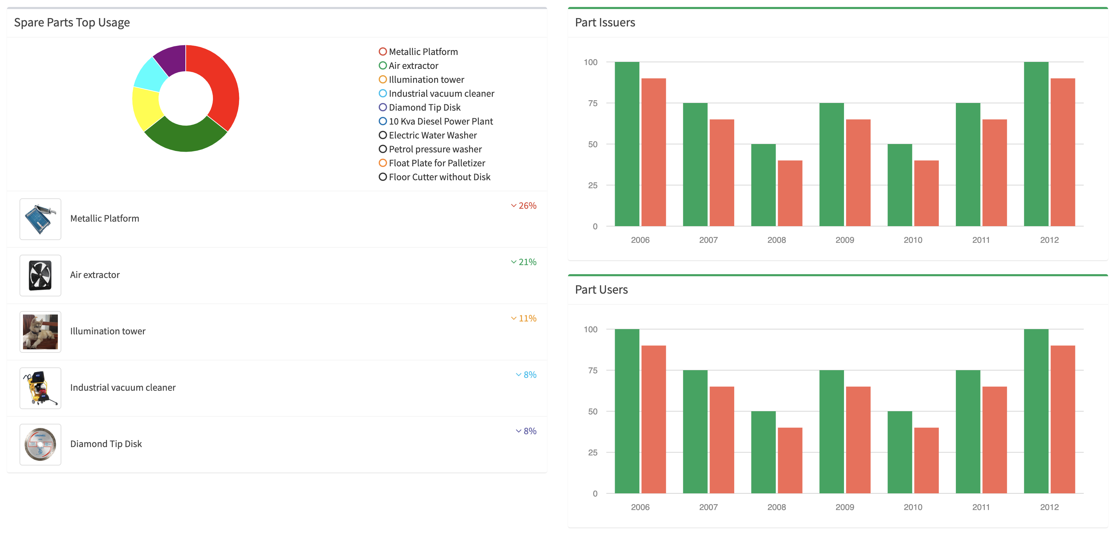

This is to display the issuers and its total amount of parts issued

Issuer Bar Chart

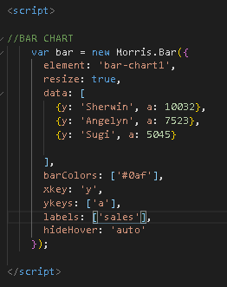 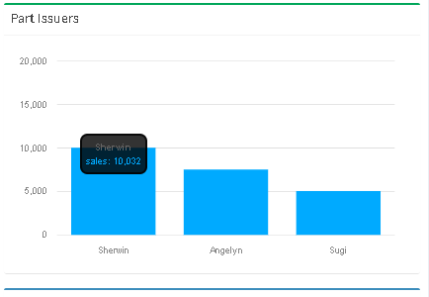

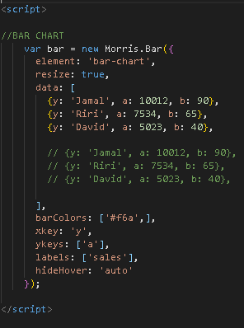 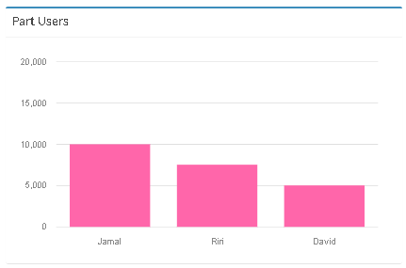

* Make the data dynamic with Issuers in reference with sales and column of the db and cross check the issuer code with the users table to get the name of the issuer.
* The total withdrawal will be computed per issuer
* Use the ctrShowWithdrawal and ctrShowUSers controllers

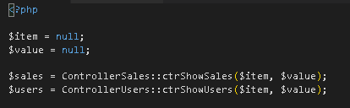

* Create a foreach for each sales and let it value as $valueSales, then to crosscheck the users make another foreach under $valueSales and make it as $valueUsers. Create an if statement to check the relationship from the column idIssuer and make an array_push for the outcome. Store this in an array.

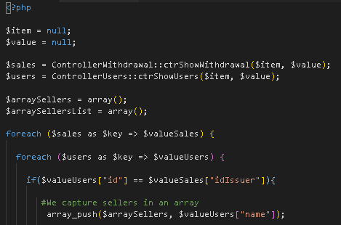

* Capture the netPrice



* Compute the net price withdrawn by each issuer

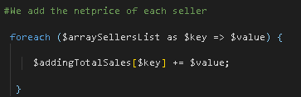

* Use the array_unique to ensure no duplicate names

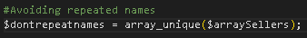

* Put the data in the graph. Open a php tag

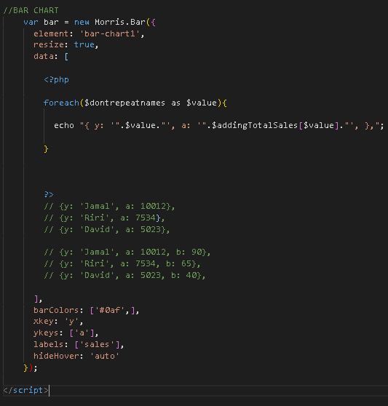

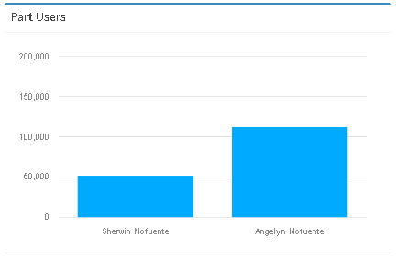

* Now work on the partsUsers. Utilize the showWithdrawal and showpartsUSer controllers. $item and $value = null will bring all the data from db
* Same method as the graph for parts Issuer. Here we utilize the sales and compute its total per parts User

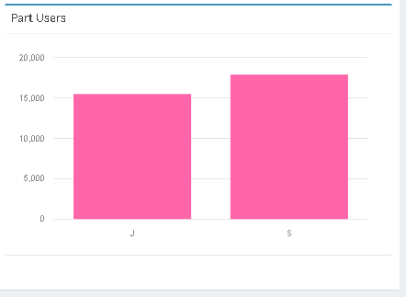

1. Download Withdrawal in excel

Create the “Export to Excel” button in the reports.php in line with the daterange picker

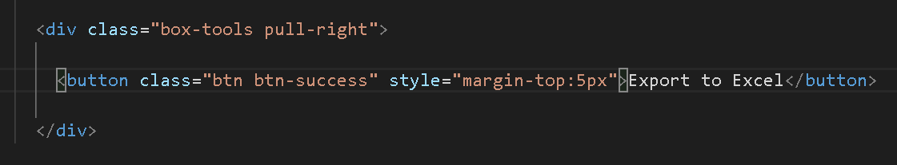

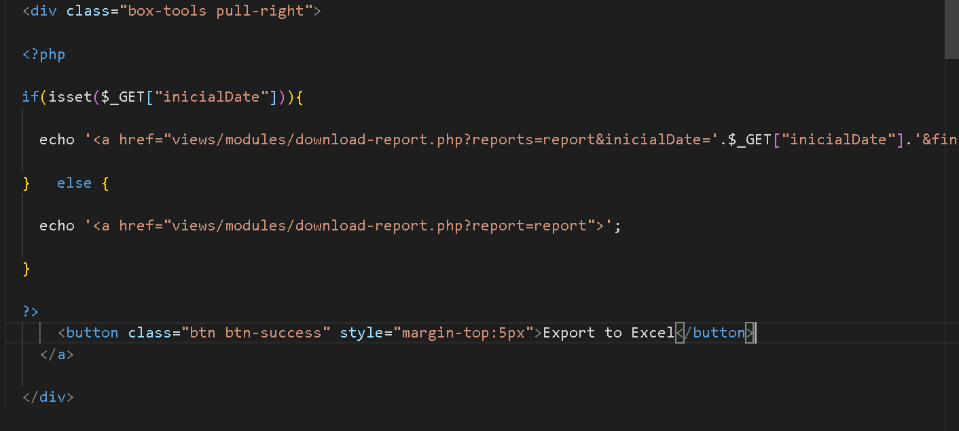

Create the download-report.php an create the ctrDownloadReport

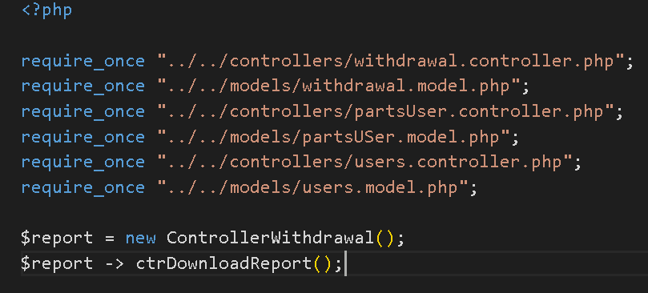

Create the controller ctrDownloadReport

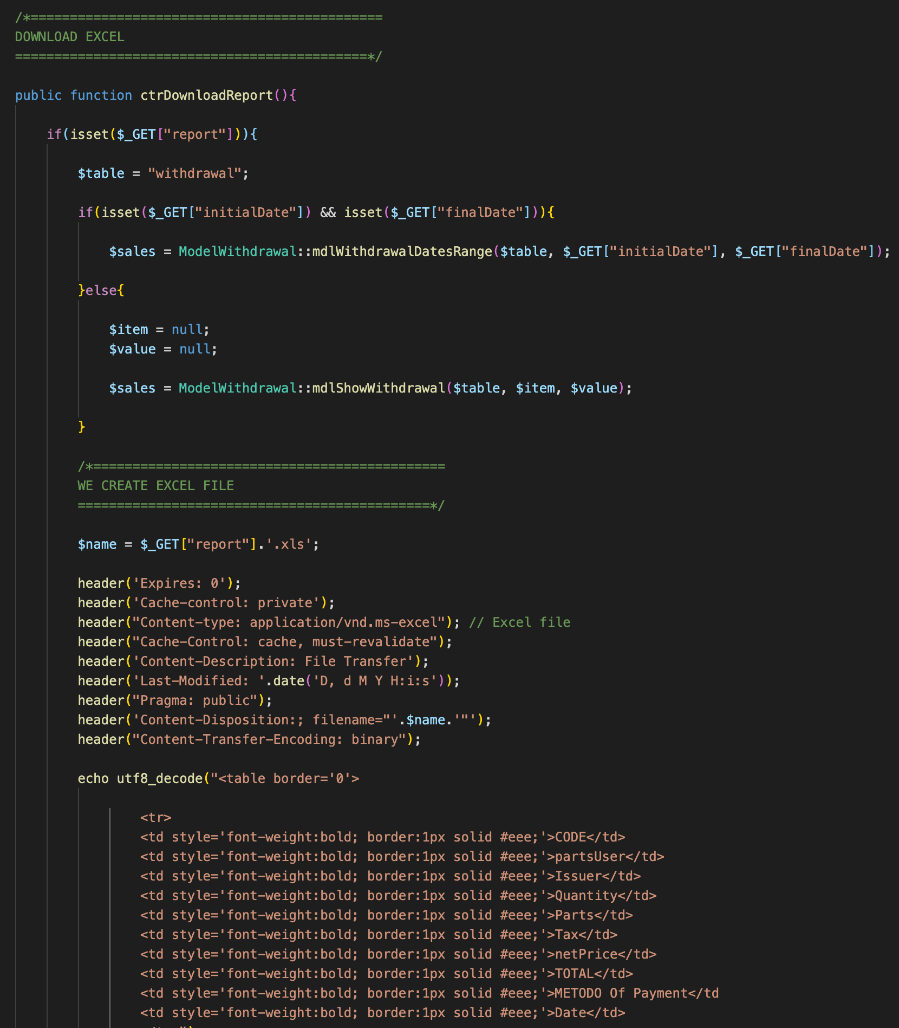

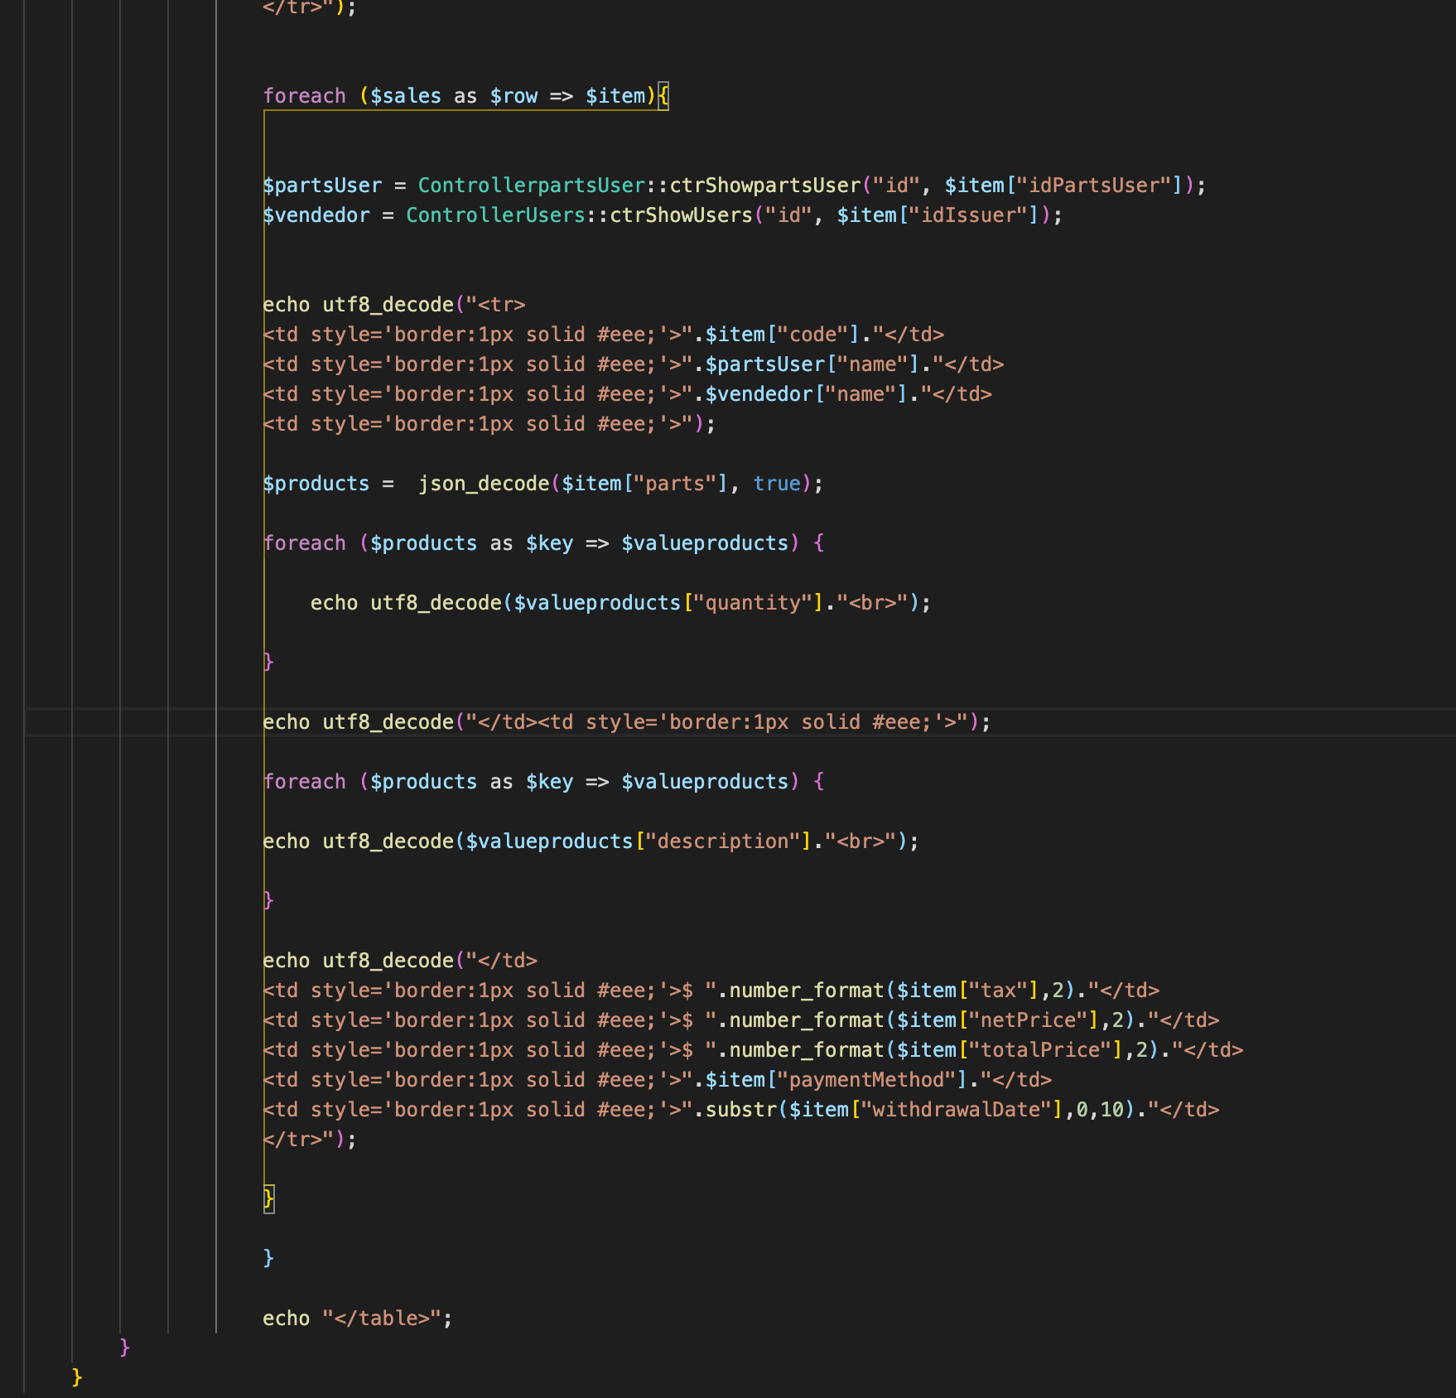

1. Correction in sales report

* In partsUSerG.php, put the idPartsUser in if statement

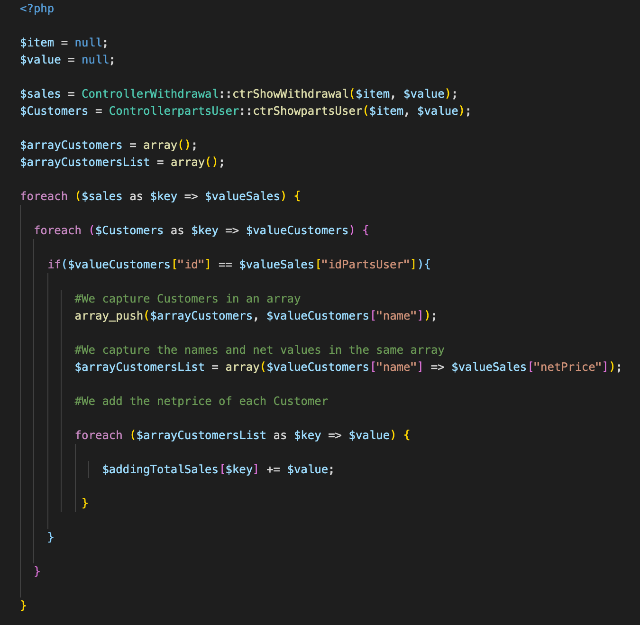

Do it also for Issuers as they don’t add up in the reports.php

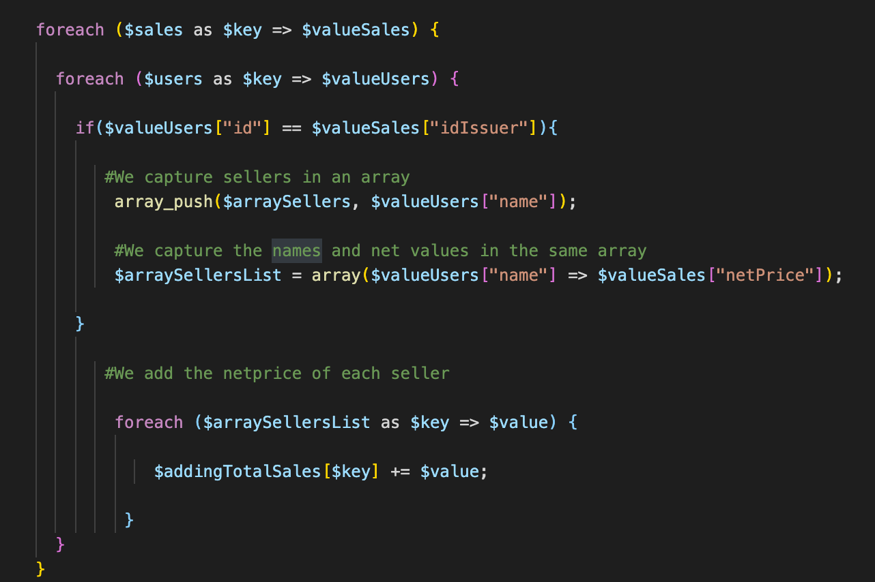 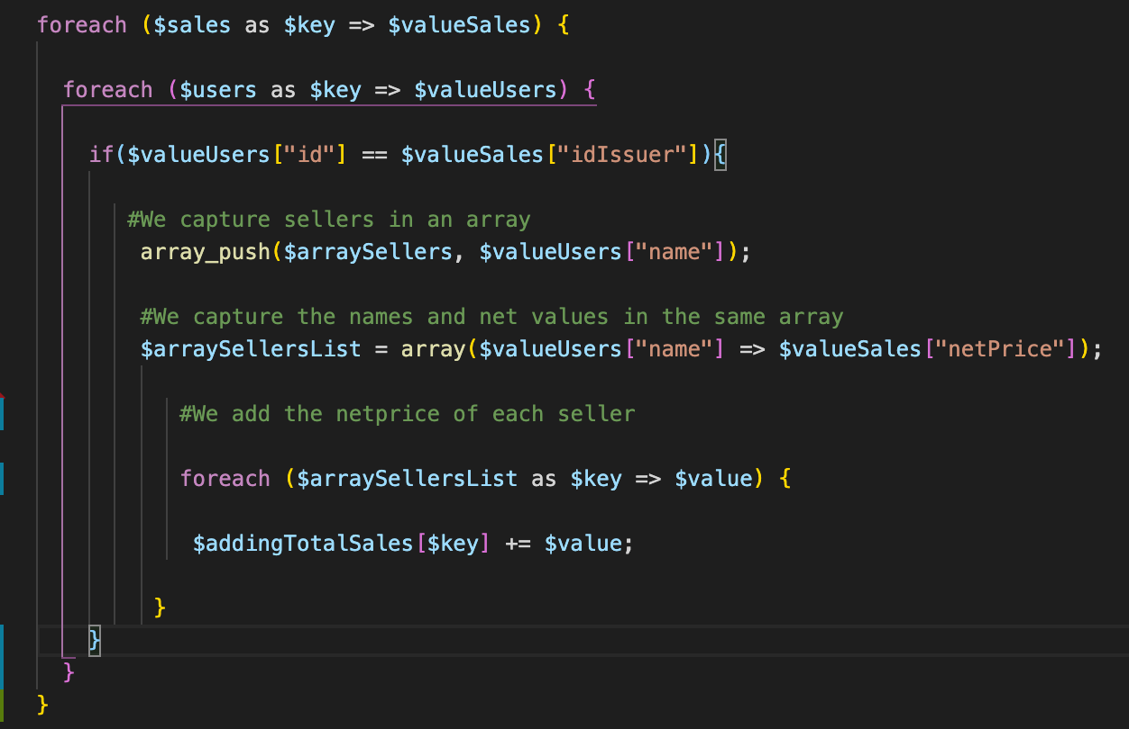

1. Dynamic data for homepage

In home.php remove the content of the <section>. Create a folder home inside the views. Start building the top boxes.

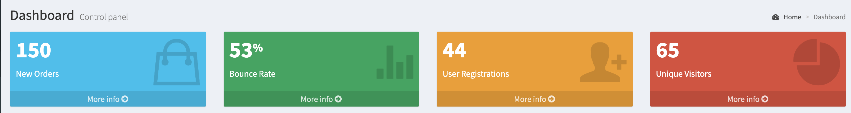

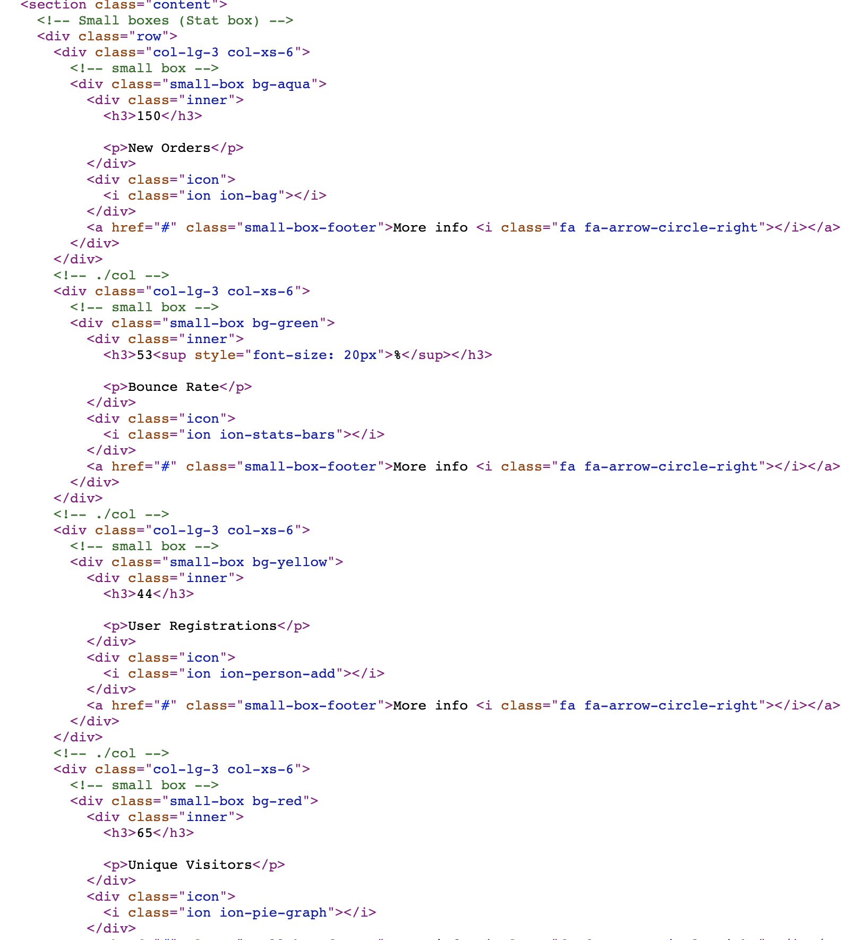

Customize the top boxes

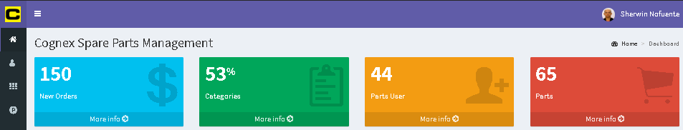

Make the data dynamic to each boxes. In withdrawal.php, create a controller to compute the total of the column netPrice

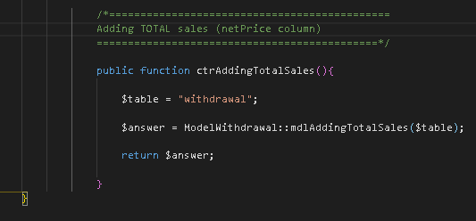

Create the mdlAddingTotalSales. Use the function SUM of the SQL

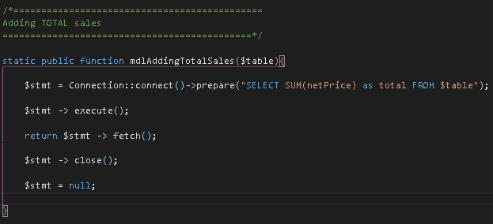

In top-boxes.php, open a php tag to use the withdrawal.controller.php and the ctrAddingTotalSales

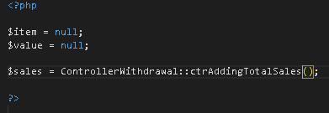

Then use the value to make the data from static to dynamic

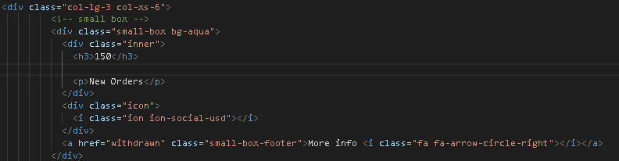 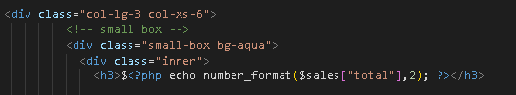

The dynamic data is now displayed with2 decimal points

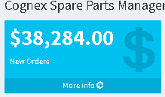

Bring the dynamic data for categories. Use the ctrShowCategories and mdlShowCategories from categories.controller and categories.model. in top-boxes.php

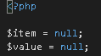 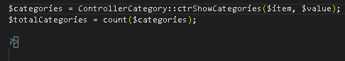

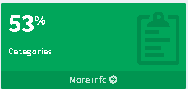 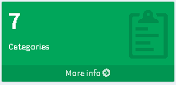

Dop the same thing for partsUser and Parts count

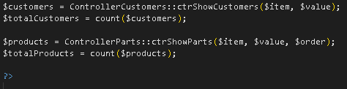

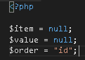

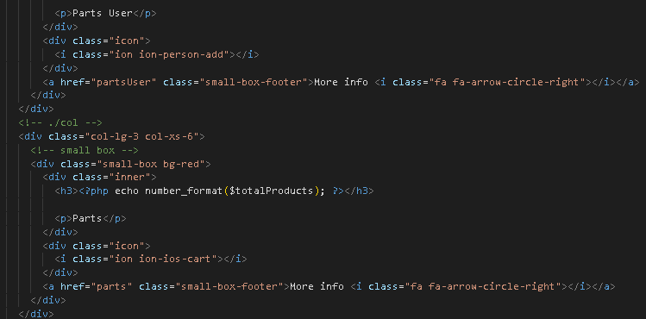

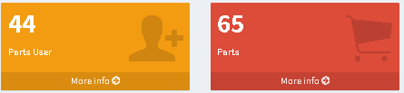

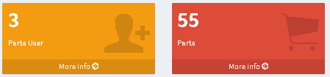

* Add the sales graph in the home page. At home.php, add another row

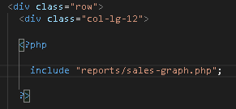

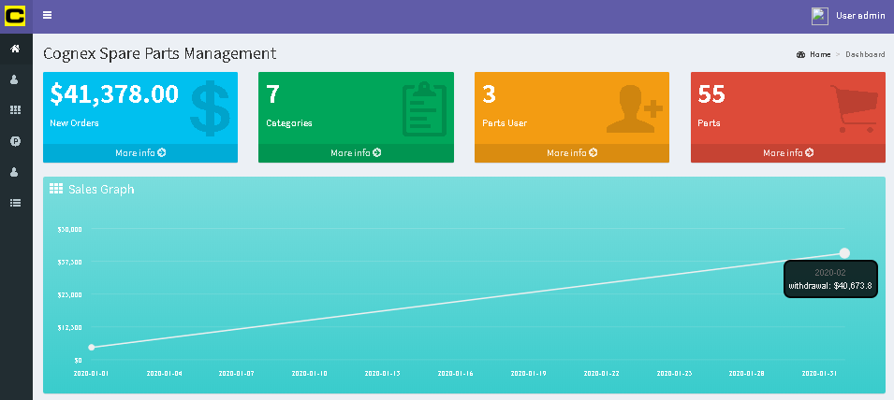

* Create the most withdrawn parts graph in home page

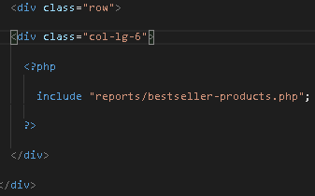

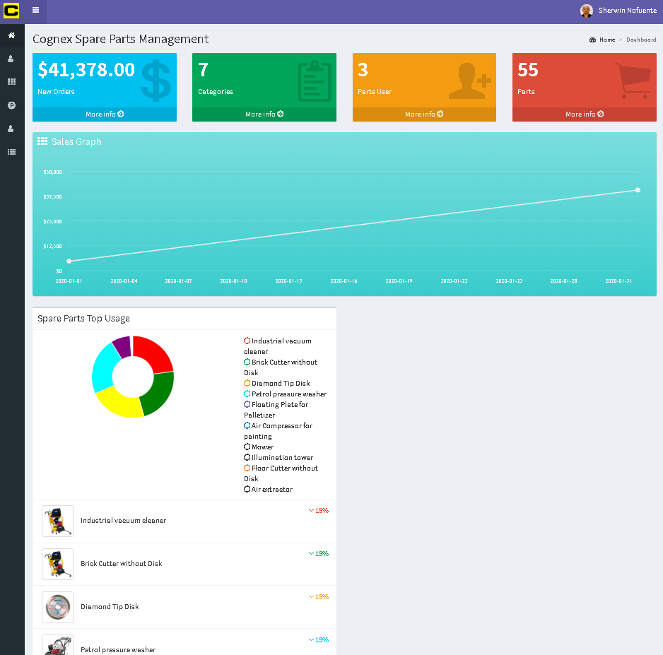

* Create the recently added parts. create the recent-parts.php in home folder

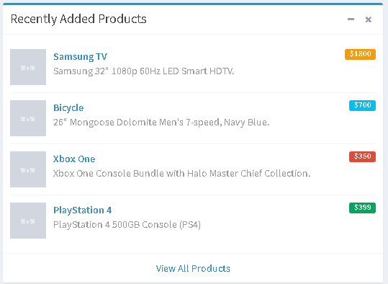

* 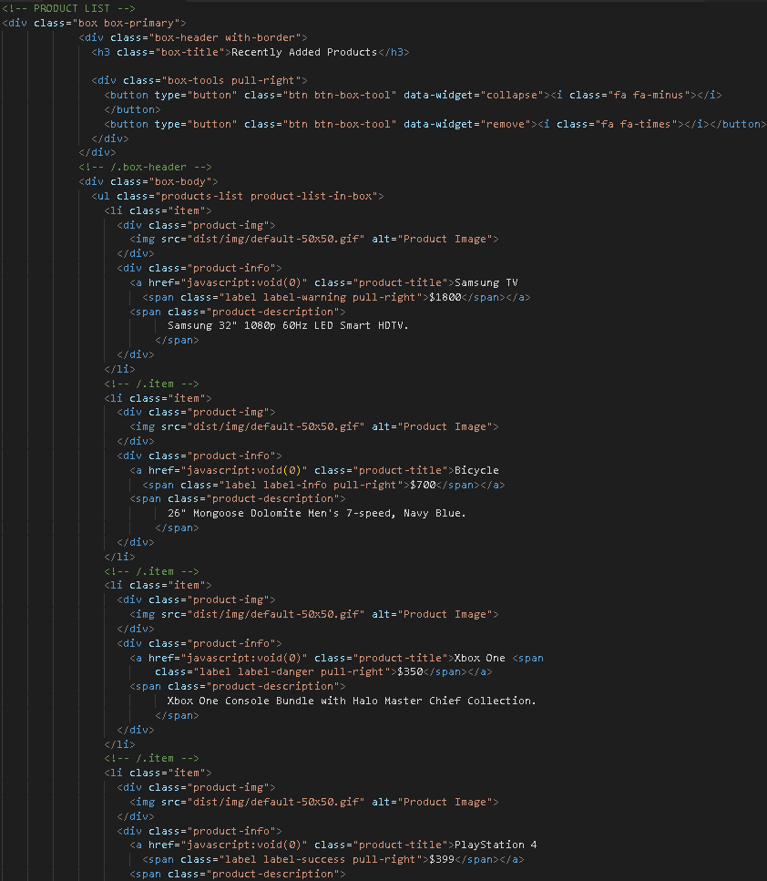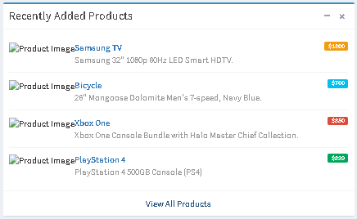Open adminlte and copy the html into
* Bring in the dynamic data. List the parts from parts.controller.php by utilizing the ctrShowParts

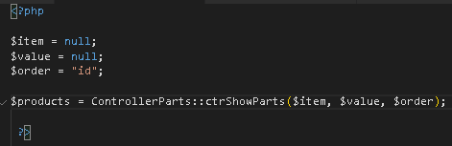

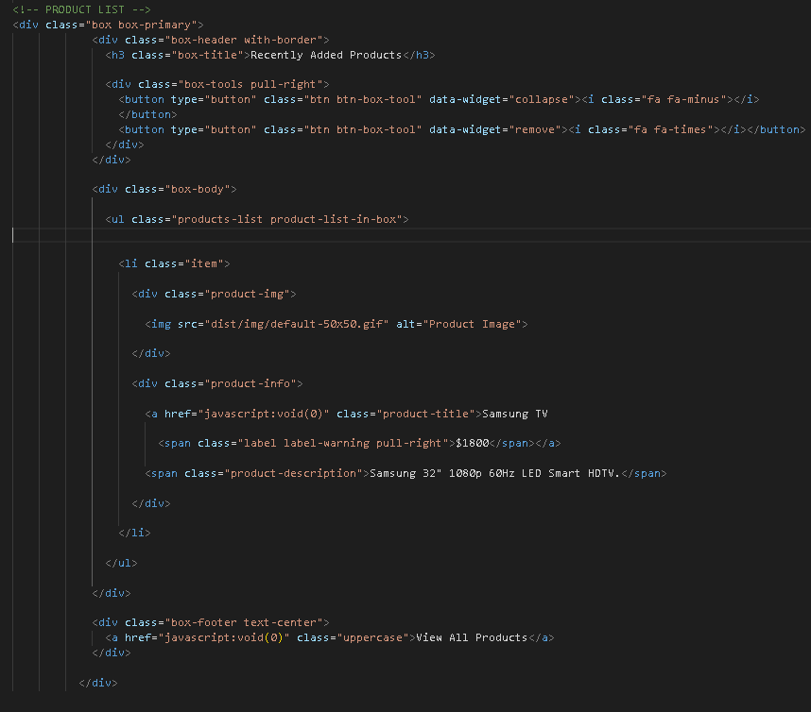

Bring in the data in this li

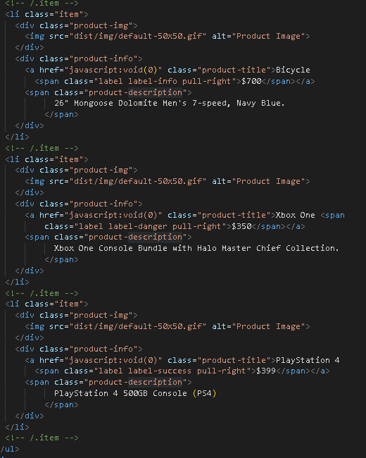



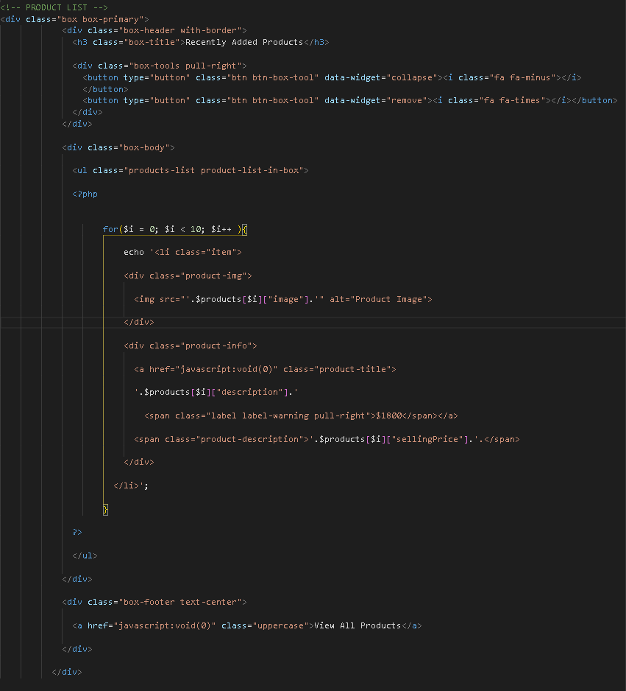

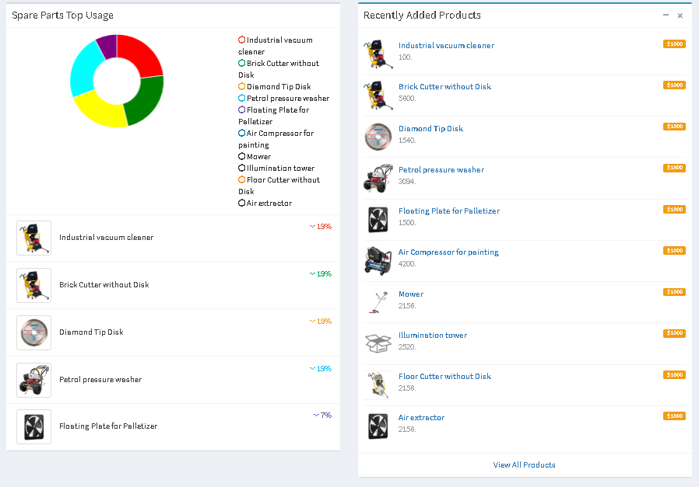

1. User roles according to profile

Administrator – full access

Seller – can create sales, cannot delete anything and can’t edit for anything

Special – person that can create product categories but can’t create product, can edit and add but can’t delete

In home.php, create an if statement for Administrator for the graph in the homepage

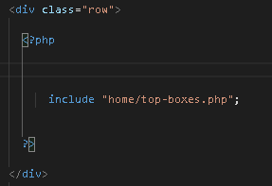 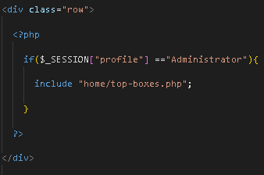

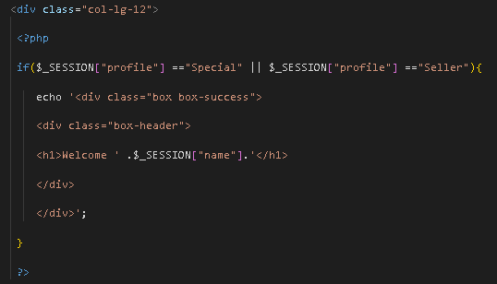

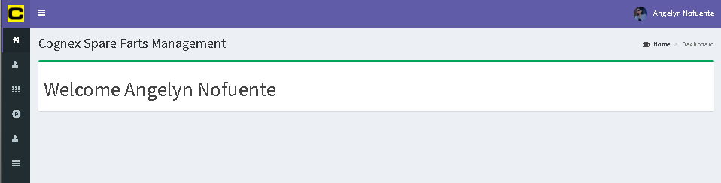

At menu.php

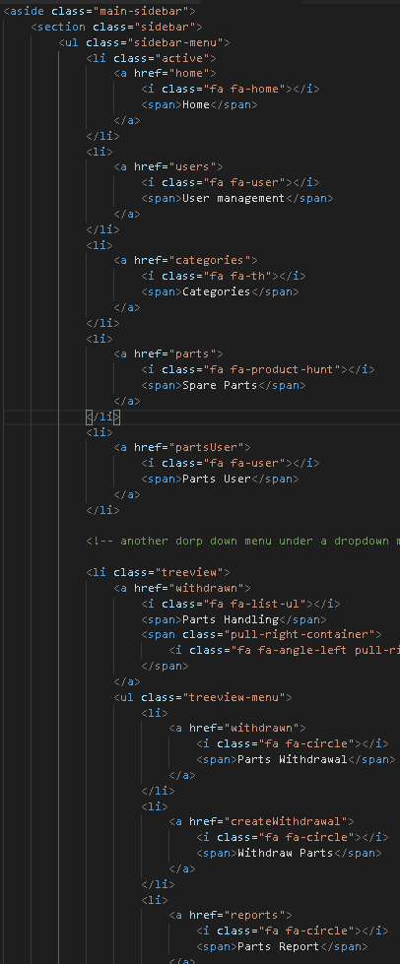 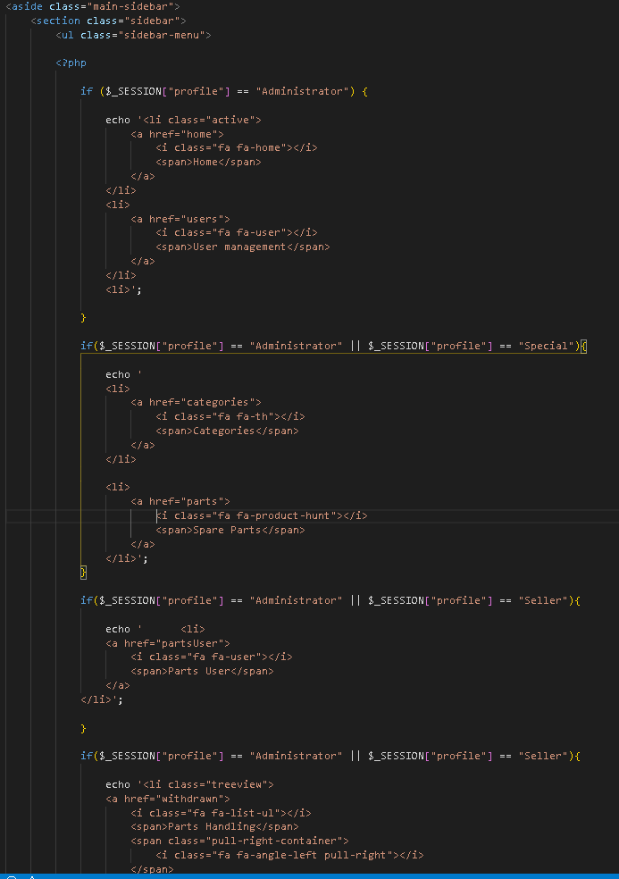

At partsUser.php,

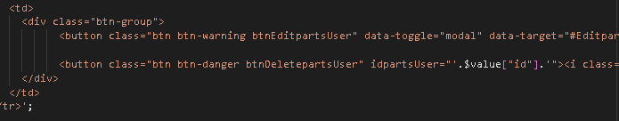

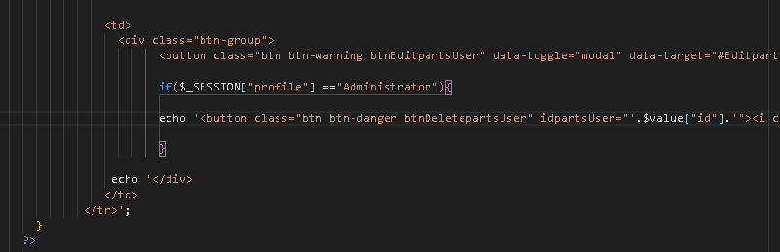

From here, only the administrator has the power to delete partsUser. Do this for the withdrawal page

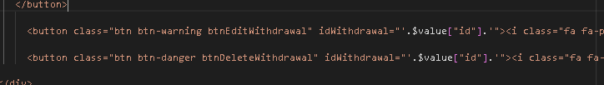

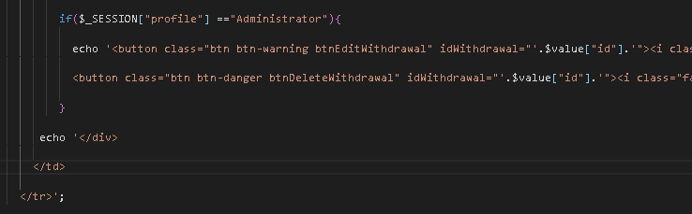

From here the seller can only print the sales

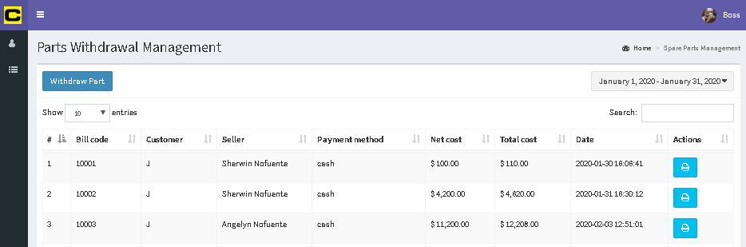

* For Special profile – available are only categories and products

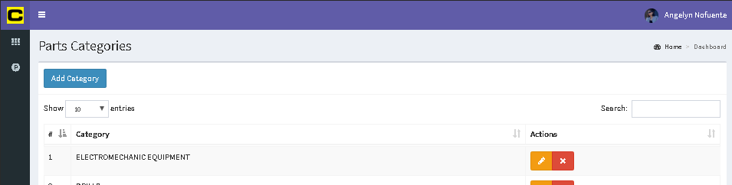

At categories.php, make the seller not be able to delete any categories by hiding the dlete button

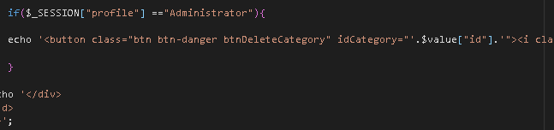

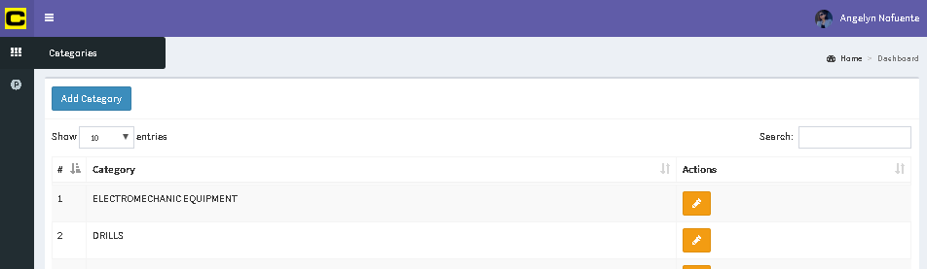

For parts in parts.php

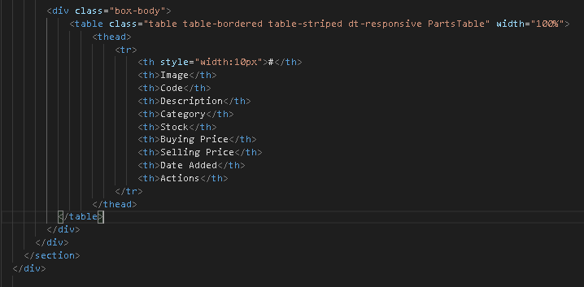

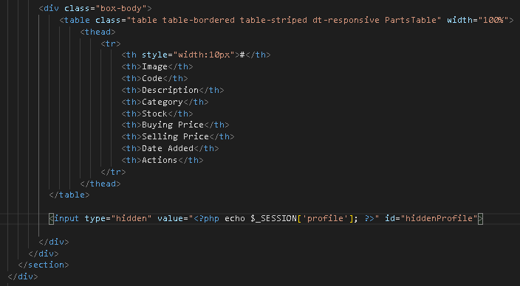

Then in parts.js, create the hidden profile to identify the kind of profile that logged in. this is more complicated as it’s inside the dataTable

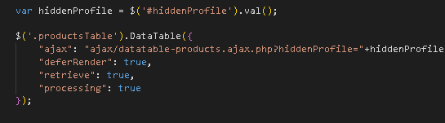

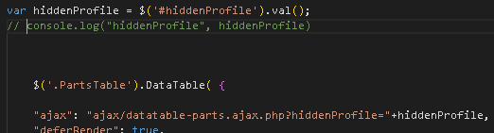

Then at datatable-parts.ajax.php

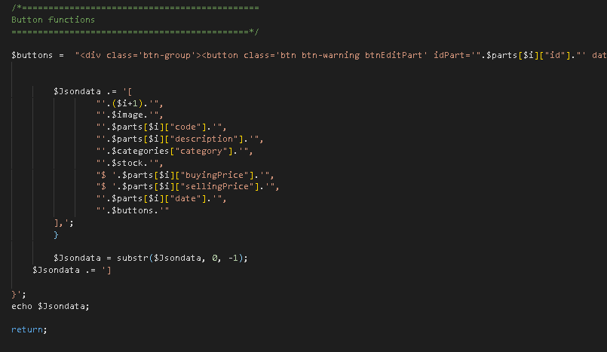

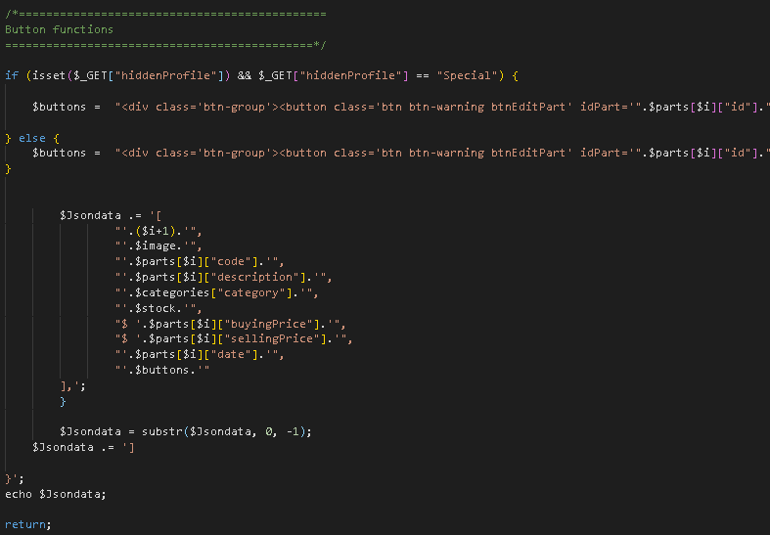

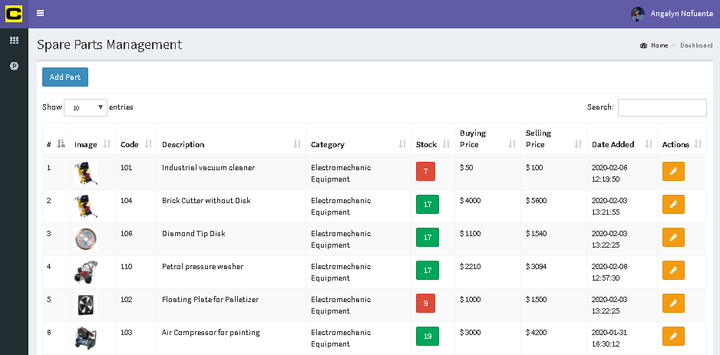

Avoid entering unrestricted pages by seller or special acct.

In categories.php

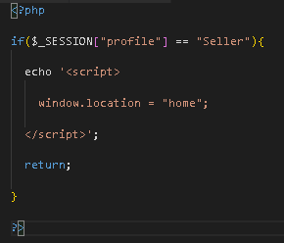

Do that also all the pages, limit the access of each pages to each profile.